**HOLE-BOTTOM SAUCERS**

These interesting diminutive dishes were produced in China primarily for export toSoutheast Asia, especially Indonesia and the Philippines, and to a lesser extent Cambodia and Thailand. They represent an interesting example of Chinese ceramic production targeted for very specific localized market needs and demands. They are distinguished primarily by their recessed base without footrim and relatively small size. Diameter is typically about 10 centimeters to 12 centimeters, but can range from 9.9 centimeters to 13.7 centimeters. The period of production was primarily late 15th century to mid 16th century.

A representative variety is included in the **Ceramics** **Catalogue**, with places and date of acquisition indicated along with the description. Examples included are blue and white, monochrome white, celadon, polychrome, and several with fish in biscuit form - all in a variety of motifs. Among the floral motifs are found magnolia blossom, floral spray, molded floral spray, peony spray, ginger plant, *lingzhi* (sacred fungus), lotus, and incised lotus blossom. Fauna examples include song bird, fish in unglazed biscuit, underglaze blue fish, shrimp, phoenix, and conch shell. Also represented are ribboned double *vajra*, cloud collar panels, trellis/diamond diaper band, *Lanca* characters, scholar with *qin* (Chinese stringed musical instrument) and attendant, *Shoulao* (Taoist god of long life and luck), and *shou* (longevity) character. The underside of the blue and white examples is very often adorned with plantain leaves radiating from the unglazed ring immediately surrounding the recessed base; the recessed base of the saucers is glazed, often with varying traces of kiln grit adhering, and without footrim. Bluish-white glaze typically covers the saucers, and the body where exposed at the unglazed areas is generally compact and cream colored.

As an illustration of decorative motifs, the decor of saucer **Catalogue Number** **M-232** is briefly described as follows: the center decorated with four large Tibetan Sanskrit *Lanca* characters encircled by a double ring of 12 and 18 repetitive *Lanca* characters of simplified version for *om* (sacred syllable) - and all surrounded by a single line border; the cavetto is undecorated. The underside is decorated with another double ring of the same Tibetan Sanskrit *Lanca* characters as the interior, but consisting of an equal number of characters (29) in each ring.

Included in the **Ceramics Catalogue** are Ming hole-bottom saucers acquired in the following locations:

Indonesia - 13 (Mainly from South Sulewesi excavations)

Thailand - 12 (Primarily from Ayutthaya riverine excavations)

Philippines - 11 (Many from Santa Cruz and Lena Shoal shipwrecks)

Cambodia - 2 (1 of which was actually acquired in Thailand)

Singapore - 2 (Probably reached Singapore via Indonesia)

Hong Kong - 4

New York - 1 (Actually from a Hong Kong collection)

London - 1

Amsterdam - 1 (Brought to the Netherlands from Indonesia)

Total = 47

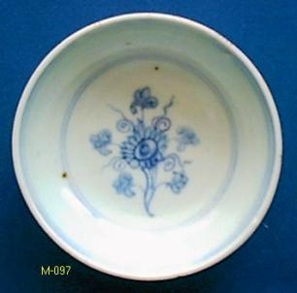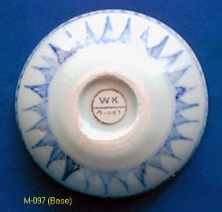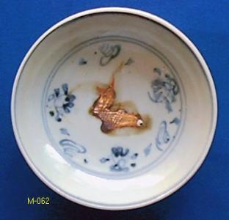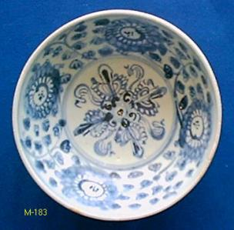

In the Philippines, for example, hole-bottom saucers are found as burial goods interred with the deceased. This is vividly illustrated from the photographs of the Excavations at Pulung Bakaw (Fox - reference cited). With respect to the production center and origin of the saucers, it has been reported that similar small dishes have been found at the Hutian and Dongjiawu kiln sites in Jingdezhen (Crick - reference cited). Unfortunately, further information on this appears to be lacking.

Ming hole-bottom items in the Collection are catalogued under 39 M (Ming) series numbers (M-005 to M-523) and total 47 items as follows:

M-005, M-006, M-031, M-058, M-062, M-096 (2 of 2), M-097, M-098, M-134, M-165, M-171, M-181, M-182, M-183, M-196, M-220, M-229, M-232, M-238, M-239, M-240, M-241, M-245, M-258, M-262, M-283, M-285 (2 of 2), M-338, M-346, M-374, M-375, M-388, M-391, M-392, M-400, M-407, M-434, M-460 (2 & 3), and M-523 (6 of 6).

Additionally, Thai hole-bottom dishes are catalogued under 3 TH (Thai) series numbers and total 3 items as follows: TH-237, TH-365 and TH-387 (No. 6 of 6). Thai saucer dishes with the “hole-bottom” base are very seldom encountered and would appear to have been produced in very limited numbers. There is also no evidence, neither published nor anecdotal, of their being exported to the Philippines or Indonesia, for example. It may be surmised, therefore, on the basis of the evidence currently available, that the Thai production of this series of saucer dishes was done in emulation of the Chinese originals. That production would appear to have been confined to limited quantities to meet the demands of the local market.

**Hole-bottom Saucers Photos** - Folder in which all the Hole-bottom Saucers, with the bases illustrated, have been consolidated; also included are copies of the **Ceramics** **Catalogue Entries** for each item.

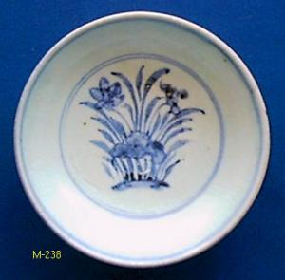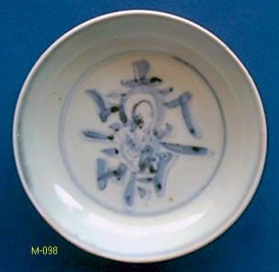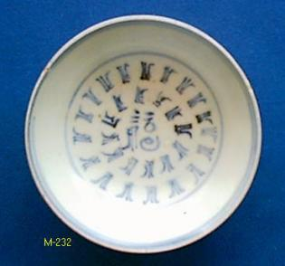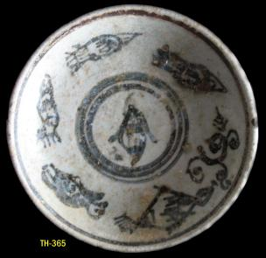

For an excellent summary and description of hole-bottom saucers the article by Southeast Asia specialist Dawn Rooney may be referred to: Dawn F. Rooney, “The Recessed Base (Hole Bottom) Saucer: A Type of Chinese Export Ware,” *Arts of Asia*, Volume 12, Number 1, January - February 1982, pages 114 to 118.

**HOLE-BOTTOM SAUCER REFERENCES (Partial Listing**)

Addis, J. M.,1968. "Some Buddhist Motifs as a Clue to Dating", *Manila Trade Pottery Seminar*, pages 10 and 11, plates 1 and 3.

Aga-Oglu, Kamer, 1972. *The Williams Collection of Far Eastern Ceramics*. Ann Arbor: Museum of Anthropology, University of Michigan.

Aga-Oglu, Kamer, 1972. *The Williams Collection of Far Eastern Ceramics: Tonnancour Section.* Ann Arbor: Museum of Anthropology, University of Michigan.

Brown, Roxanna, 1977. *The Ceramics of South-East Asia, Their Dating and Identification*. Kuala Lumpur: Oxford University Press. Second edition, 1988.

*China Westward: Chinese Export Ceramics from 12th C. to 15th C*. Exhibition Catalogue, Hong Kong: The City University of Hong Kong, 2003.

Columbus Museum of Art, 1982. *Shadow of the Dragon: Chinese Domestic & Trade Ceramics* *- Exhibition Catalogue.*

Crick, Monique, 2010. *Chinese Trade Ceramics for South-East Asia from the 1st to the 17th Century: Collection of Ambassador and Mrs. Charles Muller.* Milan, Italy: 5 Continents Editions.

Fox, Robert B., *The Excavations*, Philippine Studies vol. 7, no. 3 (1959): 390–401, Ateneo de Manila University.

Fox, R. B., *The Calatagan Excavations: Two 15th Century Burial Sites in Batangas, Philippines,* Philippine Studies vol. 7, no. 3 (1959): 321–389, Ateneo de Manila University.

Goddio, Franck, et. al., 2002. *Lost at Sea: the Strange Route of the Lena Shoal Junk.* London: Periplus Publishing London Ltd.

Locsin, Leandro and Cecilia, 1967. *Oriental Ceramics Discovered in the Philippines*. Rutland, Vermont & Tokyo: Charles E. Tuttle Co.

Macintosh, D.,1979. *Chinese Blue & White Porcelain*, Oriental Ceramic Society of Hong Kong, *South-East Asian and Chinese Trade Pottery - Exhibition Catalogue.*

McElney, Brian, 2006. *Chinese Ceramics & the Maritime Trade Pre - 1700.* Bath, England: Museum of East Asian Art.

Museum Pusat, Jakarta (Museum Nasional Indonesia) - various hole-bottom saucers on display.

National Museum of the Philippines, Manila - various hole-bottom saucers on display.

Rooney, Dawn F., “The Recessed Base (Hole Bottom) Saucer: A Type of Chinese Export Ware,” *Arts of Asia*, Volume 12, Number 1, January - February 1982, pages 114 to 118.

Sotheby Parke Bernet (New York), *Catalogue of Chinese Ceramics and Works of Art, Modern and Contemporary Chinese Paintings,* March 12, 1981, lot 167.

Southeast Asian Ceramics Museum (SEACM), Bangkok University - collections displayed and in storage.

Sorsby, William, 1974. *South-East Asian and Early Chinese Export Ce*ramics. London: William Sorsby Ltd.

The Vancouver Society for Asian Art, 1971. *The Talking Jars : An Exhibition of Oriental Ceramic Folkwares found in South East Asia.* Vancouver, Canada: Centennial Museum.

Wiesner, Ulrich, 1977. *Chinesische Keramik Auf Den Philippinen - Die Sammlung Eric E Geiling.* Koln: Museum fur Ostasiatische Kunst, Koln.

Wilson, Elizabeth, 1988. *A Pocket Guide to Oriental Ceramics in the Philippines.* Manila: Bookmark.

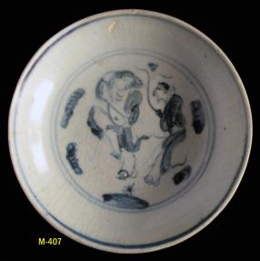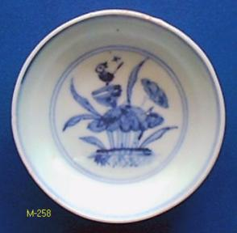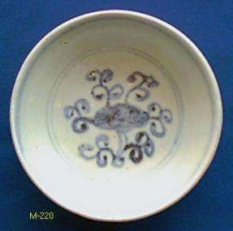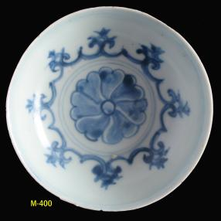

**ALL HOLE-BOTTOM SAUCERS IN CERAMICS CATALOGUE**

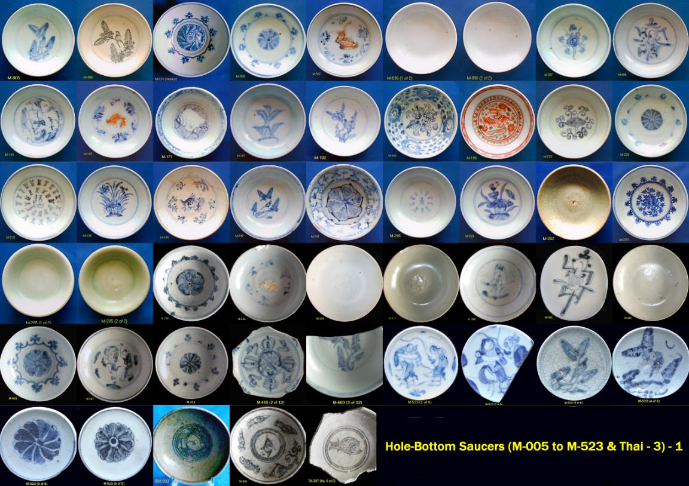

**ALL HOLE-BOTTOM SAUCERS INCLUDING THE BASE**

