**CHINESE IMARI PORCELAIN**

Presented here is a brief description of Chinese Imari porcelain produced during the Qing dynasty, which includes origin, characteristics and targeted markets, along with a list of those porcelains represented in the Ceramics Catalogue.

Chinese Imari porcelain is adorned in a combination of underglaze blue, overglaze iron-red enamel, and gold. It was manufactured at Jingdezhen from the early to mid-18th century during the latter part of the reign of the Kangxi emperor (1662 to 1722) to the earlier part of emperor Qianlong’s reign (1735 to 1796). Chinese Imari porcelain was produced in response to the popularity of Japanese Imari wares in Europe, emulating and intending to compete with them. The Chinese version is more thinly potted, has thinner and more uniform glaze, and the underglaze blue is of much finer quality than the Japanese counterparts. The decorative motifs of Chinese Imari are sometimes a copy of the Japanese wares, but usually are based on the typical Chinese underglaze blue motifs of the period including landscapes, flowering plants, birds, various diaper patterns, symbols, sometimes human figures, and occasionally mythical creatures. The shapes produced were of the standard export variety including bowls, cups, plates, saucer dishes, teapots, and jars. In limited instances green glaze (and sometimes black) was added to the palette, and the resultant wares are referred to as “Verte-Imari.”

In addition to Europe, market demand for Chinese Imari porcelain was also strong in Southeast Asia, India, and the Ottoman Empire. In fact, the collection of the Topkapi Saray Museum contains an extensive array of Chinese Imari porcelains produced from the early 18th century to the early to mid-18th century as illustrated in Regina Krahl, *Chinese Ceramics in the Topkapi Saray Museum Istambul, Volume IIl - Qing Dynasty Porcelains,* pages 1197 to 1253.

The largest quantity of Chinese Imari ware recovered from a shipwreck context was found on the Nanking Cargo (Geldermalsen) shipwreck dated to 1751 of the Qianlong period and discovered in Indonesia. The Ca Mau shipwreck, dated to 1725 of the Yong Zheng period (1723 to 1735) and found in Vietnam, yielded a much more limited amount of Chinese Imari wares, but did include complete tea sets. The galleons of the 1715 Spanish Treasure Fleet (sunk 31 July 1715 on the reefs off the Florida coast between Melbourne in the north to Fort Pierce to the south) also transported some Chinese Imari wares, very limited quantities of which (almost exclusively

shards) have been recovered. Other shipwrecks with Chinese Imari wares in the cargo include the following:

* Beeswax Shipwreck (dated late 17th century - 1693) and found on the Pacific coast of the USA in northwest Oregon, with 2 shards out of 1577 recovered shards identified as Chinese Imari ware (displaying gold gilt pine branches with red overglaze and underglaze blue).
* Pingtan No. 1 Shipwreck (dated to circa 1700) and found on Wanjiao Reef near Pingtan Island in Fujian Province, China may possibly have contained some Chinese Imari wares, but this has not yet been confirmed.
* Götheborg (dated 1745) and found in Sweden had a limited quantity of Chinese Imari wares confined apparently to “lidded sugar bowls” and some plates.
* Sadana Island Shipwreck (dated 1765) and found off the Red Sea Coast of Egypt with an excess of a quarter of the excavated porcelain consisting of Chinese Imari wares.

Chinese Imari wares in the **Ceramics Catalogue** are represented by the Nanking Cargo (11), Ca Mau (3), the 1715 Spanish Treasure Fleet (1), and the Götheborg shipwreck (1) as follows:

**Nanking Cargo:** **C-073** - cup and saucer (set) with pagoda, trees, and rocks in landscape setting; **C-074** – plate with pagoda, rocks, and fishing boat; **C-109** - cup and saucer (set) with ornamental rock and peony bushes; **C-138** – saucer with pagoda, trees, and rocks in landscape setting; **C-154** - cup and saucer (set) with pine trees and grasses on terrace, trellis diaper; **C-155** - cup and saucer (set) with pine trees and grasses on terrace, trellis diaper; **C-239** - globular teapot with pavilion, terrace, and trees in landscape scene.

**Ca Mau: C-160** - small chrysanthemum form shallow bowl with floral sprays and fluted sides; **C-244 (5 of 8)** - tray hexagonal shaped (fragment), interior pavilion setting; **C-244 (6 of 8)** - tray elongated oval shaped (fragment), interior pavilion setting.

**1715 Spanish Treasure Fleet: C-258 (3 of 4)** -side of vase (fragment) with leaf sprays, chrysanthemum and lotus blossoms.

**Götheborg shipwreck: C-076 (5 of 11) –** plate with overglaze décor including red enamel blossoms along with underglaze blue accents.

**C-073 - Catalogue Entry:**

Chinese Imari cup (small bowl) and saucer (2 - set) very thinly potted and decorated in a vibrant tone of underglaze blue with a pagoda flanked by trees and outcropping rocks in a landscape setting. The saucer further adorned with a rock formation across from the pagoda, and the cup adorned with a leafy bush on the side opposite the pagoda. Encircling the upright rim of the saucer a rather widely spaced double line border, a single line border on the cup. The underside of the saucer is undecorated as is the interior of the cup, except for a triple line border under the upright mouthrim. Foot of the saucer is wedge shaped, and on the cup the upright foot is vertical on the exterior and interior.

Both the cup and saucer with compact fine grained white colored biscuit where exposed at the beveled footrim. Glazed base of both cup and saucer is convex. Cup and saucer are covered with a slightly bluish tinged glaze. Some traces of the polychrome enamels and gilt originally accenting the central motifs remain on both the cup and saucer. However, most of the enameling is substantially eroded due to the prolonged immersion in seawater. In the reference cited below this cup and saucer are described to be of the “Blue and enameled Imari Pavilion pattern.”

D: 3 in. (7.7 cm.) - cup; and D: 4 5/8 in. (11.6 cm.) - saucer.

Qing: 1751 of Qianlong period (1735 to 1796).

Provenance: **Nanking Cargo** (Geldermalsen) shipwreck, Indonesia -

acquired from Singapore shipwreck ceramics specialist dealer Koh -

Antique (original Koh Antique sticker number 960 affixed to the cup

and sticker number 954 affixed to the saucer) – (August 2008).

For a cup and saucer in this series see Christie’s Amsterdam, *The Nanking Cargo: Chinese Export Porcelain and Gold, European Glass and Stoneware*, *Auction Catalogue*, 28 April - 2 May 1986 (lot number 5189). Very similar cups and saucers, also from **the Nanking Cargo** shipwreck, are illustrated in Colin Sheaf and Richard Kilburn, *The Hatcher Porcelain Cargoes, The Complete Record*, page 107, Pl. 142.

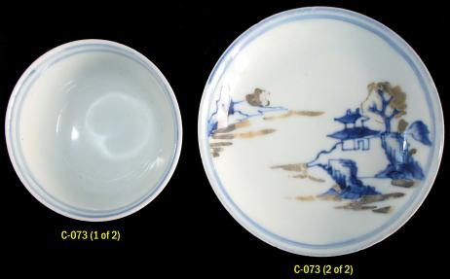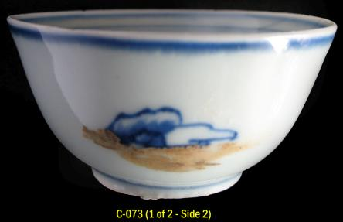

**C-074 - Catalogue Entry:**

Chinese Imari plate decorated in a vibrant tone of underglaze blue with a riverine setting featuring a pagoda flanked by rock forms with vegetation, outcropping rocks above. The plate adorned further with a rock formation on the side opposite the pagoda and with a small fishing boat in the foreground. A narrow band of overglaze fleuron tips encircles the shallow cavetto. The wide flattened rim adorned with a total of six fruit, floral and leaf sprays enclosed within double line borders. The fruit sprays include pomegranate and peach. Encircling the rounded rim near the edge a single line border and a narrow band of overglaze trellis diaper immediately below.

The underside of the plate is undecorated. Foot is wedge shaped with compact and fine grained cream colored biscuit where exposed at the unglazed beveled footrim. Base is flat and covered with lustrous slightly bluish tinged white glaze. Some traces of the polychrome enamels and gilt originally accenting the central motifs and borders remain. However, most of the enameling is substantially eroded due to the prolonged immersion in sea water. In the reference cited below on page 173 this plate is described to be of the “Boatman and Six - Flower Border pattern, blue and enamels.”

D: 9 in. (22.8. cm.).

Qing: 1751 of Qianlong period (1735 to 1796).

Provenance: Nanking Cargo (Geldermalsen) shipwreck, Indonesia - Christie’s Amsterdam, *The Nanking Cargo: Chinese Export Porcelain and Gold, European Glass and Stoneware, Auction*, 28 April - 2 May 1986 (original Christie’s sticker lot number 2023 affixed) - acquired from a dealer in America (August 2008).

“Blue and white Boatman and Six - Flower Border pattern” plates from the Nanking Cargo shipwreck, are illustrated in Colin Sheaf and Richard Kilburn, *The Hatcher Porcelain Cargoes, The Complete Record*, page 120, Pl. 160.

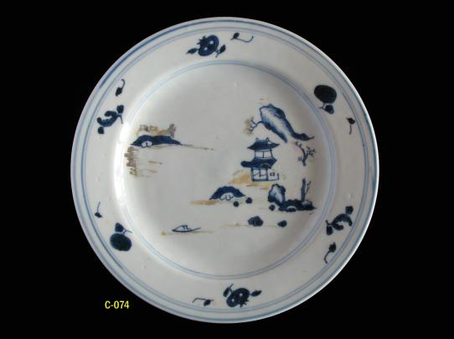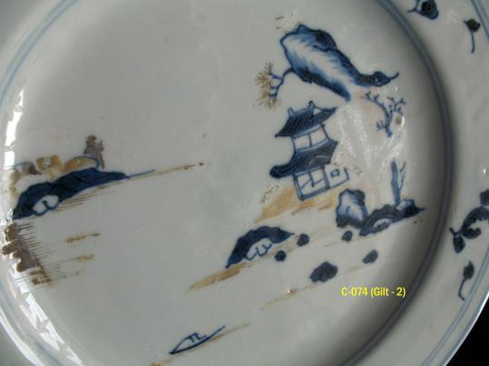

**C-244 - Catalogue Entry (No. 5 and No. 6 of 8 Refers)**:

Ca Mau shipwreck study collection stand and tray fragments (8) from tea sets and related sets consisting of blue and white, Chinese Imari (underglaze blue, with the iron-red and gilt now eroded), polychrome enamel, and monochrome-white pierced examples. Decorative motifs include female figures in a garden setting, floral and leaf sprays, interior scenes, and pierced blossoms. The trays are in a variety of shapes and with various rim treatments. All of the fragments have a flat unglazed base with compact, fine textured and light cream colored body (russet tingeing on fragment No. 7). There is a moderate amount of marine encrustation on the interior of fragment No. 2. On the four blue and white examples (No. 1 to No. 4) there are similarly rendered leaf spray accents on the sides; the sides on the two Chinese Imari examples (No. 5 and No. 6) are plain. Although no trays comparable to fragment No. 7 (originally with polychrome enamel floral décor) are illustrated, associated cups and saucers and teapots were included in *Tau Co Ca Mau (The Ca Mau Shipwreck*) as referenced below. Six of the fragments (Nos. 1 to 4, No. 7 and No. 8) represent examples which were not included in the Auction, and with four of the six (No. 2, No. 3, No. 4 and No. 7) also not included in *Tau Co Ca Mau (The Ca Mau Shipwreck*) as detailed in the chart below. Considering the foregoing, it may be inferred there were significantly more tea sets and related sets included in the original cargo, in terms of variety and quantity, than previously documented and published.

Indicated in the chart below are the following: the shape and décor of each fragment; corresponding items in the same series of the

fragments as illustrated in Sotheby’s (Amsterdam), *Catalogue* *for Made in Imperial China – 76,000 Pieces of Chinese Export Porcelain from the Ca Mau Shipwreck, circa 1725,* January 29 - 31, 2007; and in Nguyen Dinh Chien, *Tau Co Ca Mau (The Ca Mau Shipwreck*); and the diameter (D) or length (L) in centimeters of each fragment. Also indicated is the name of the décor as referred to in the Sotheby’s Auction Catalogue (fragments No. 5 and No. 6).

|  |  |  |  |  |
| --- | --- | --- | --- | --- |
| **CA MAU SHIPWRECK STUDY COLLECTION STANDS & TRAYS**  **C-244 (1 OF 8) TO C-244 (8 OF 8)** | | | | |
| **NUMBER** | **SHAPE & DÉCOR** | **REFERENCE**  **Sotheby’s Auction Catalogue** | **REFERENCE**  ***Tau Co***  ***Ca Mau*** | **D/L**  **CM** |
| C-244  (1) | Quatrefoil shape, flattened rim with cross-hatch diaper; floral sprays, with leafy stems. | **None** | Page 107, N. 24 and page 227, N. 360, “Dish” | D:  15.7 |
| C-244  (2) | Lobed quatrefoil shape, flattened rim with cross-hatch diaper; aristocratic lady at desk in garden setting. | **None** | **None** | D:  15.9 |
| C-244  (3) | Lobed shape, flattened rim with cross-hatch diaper; aristocratic lady standing in garden setting; Constellation Orion above. | **None** | **None** | L:  14.9 |
| C-244  (4) | “T” shape, narrow flattened plain rim; three floral sprays. | **None** | Page 107,  N. 25, “Dish” | L:  14.2 |
| C-244  (5) | Hexagonal shape, upright rim with floral panel band below, slanted fluted sides; interior pavilion setting (Chinese Imari). | Page 238, lot 1071; pages 240 to 242, lots 1073 to 1094, “Chinese Imari Pavilion,” stand | **None** | L:  8.9 |
| C-244  (6) | Elongated oval shape, upright rim with floral panel band below, slanted fluted sides; interior pavilion setting (Chinese Imari). | Page 238, lot 1071 and pages 240 to 241, lots 1073 to 1086, “Chinese Imari Pavilion,” spoon tray | Page 183,  N. 243, “Dish” | L:  8.5 |
| C-244  (7) | Lobed quatrefoil shape, flattened rim; traces of original polychrome enamel décor remain visible in reflected light including floral sprays, blossoms and leaves. | **None** | **None** - Page 196, N. 277, cup and saucer; page 198, N. 282, teapot (for comparison) | D:  15.9 |
| C-244  (8) | Indeterminate shape, band of pierced circles under upright rim; pierced blossoms on pierced circle ground. | **None** - Page 187, lot 791, associated “pierced strainer” for comparison (only one in Auction) | **None** | L:  10.6 |

Qing: Yong Zheng period (1723 to 1735) - circa 1725.

Provenance: Ca Mau shipwreck, Vietnam - acquired in Saigon

(January 2016).

Published: *Southeast Asian Ceramics Museum Newsletter*, Volume X Number 3, Feb – May 2017, “Ca Mau Shipwreck – New Discoveries (Part II),” illustrated on page 1 - C-244 (No. 1 to No. 8), and page 3 – C-244 (No. 3).

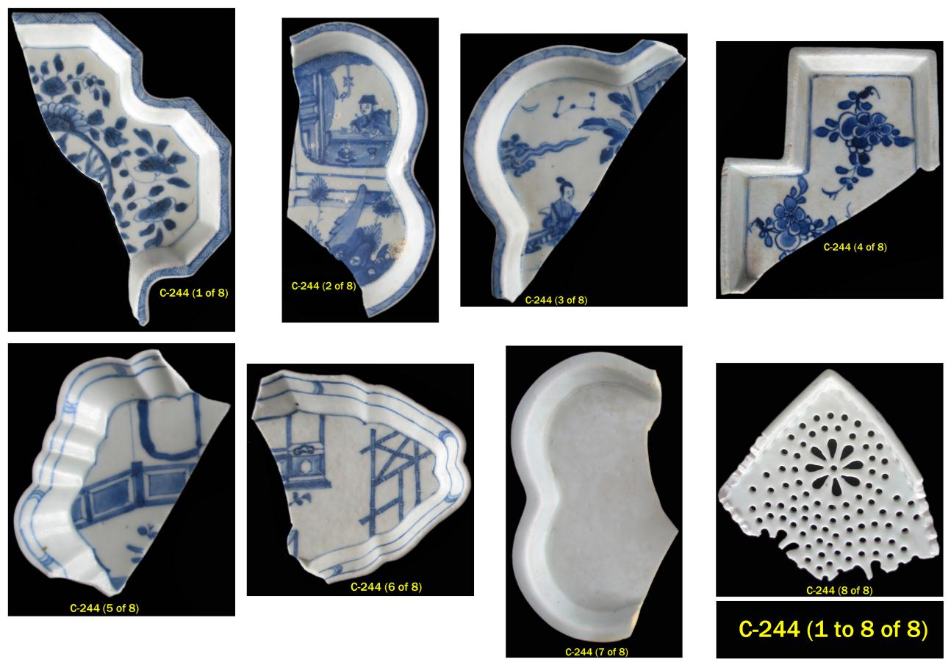

**Constellation Orion - t**he representation of a stellar body, as in the example of the Constellation Orion, which is clearly depicted on tray fragment No. 3, is quite unusual to encounter on Chinese ceramics. Based on preliminary research and review, the extremely few recorded examples identified with constellations appear to be confined to the first half of the 18th century. Further research will likely add to these preliminary findings. Also of note, for example, is that out of the several hundred Chinese ceramics in the Ceramic Catalogue this is the only one so adorned.

Ancient Chinese astronomers knew Orion as Shen (参宿) - a great hunter or warrior. According to traditional Chinese astronomy, the sky was divided into four quadrants, each quadrant representing a season of the year. The constellation Orion lies across two of the quadrants, symbolized by the White Tiger of the West - Xī Fāng Bái H**ǔ** (西方白虎) and the Vermilion Bird of the South - Nán Fāng Zhū Què (南方朱雀). The name of the Orion constellation in modern Chinese is Liè Hù Zuò (**猎户座**), meaning the hunter constellation.

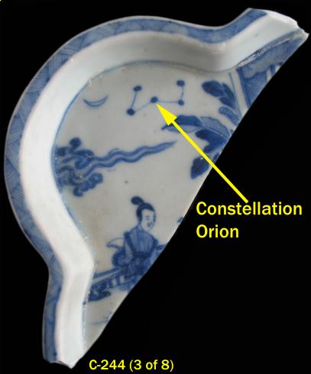

**References**

Burgess, Robert F., and Carl J. Clausen, 1982. *Florida's Golden Galleons: The Search for the 1715 Spanish Treasure Fleet*. Port Salerno: Florida Classics Library.

*Donghai Pingtan Wanjiao Yihao Chushui Ciqi* (*Ceramics Recovered from the No. 1 Wreck on Wanjiao Reef Near Pingtan on the East China Sea*), *2006.* Beijing: Science Press.

Krahl, Regina, 1986. *Chinese Ceramics in the Topkapi Saray Museum Istambul, Volume III - Qing Dynasty Porcelains.* Convent Garden, London: Philip Wilson Publishers Ltd.

Lally, Jessica, 2008. *Analysis of the Chinese Porcelain Associated with the “Beeswax Wreck*,” *Nehalem, Oregon*. Unpublished Master’s thesis, Department of Anthropology, Central Washington University, Ellensburg, Washington.

Lally, Jessica, 2009. *Analysis of the Beeswax Shipwreck Porcelain Collection*. Oregon, USA: Harvard - Yenching Institute.

Marken, Mitchell W., 1994. *Pottery from Spanish shipwrecks, 1500-1800*. Gainesville, Florida: University Press of Florida.

Medley, Margaret, 1989. *Illustrated Catalogue of Ming and Qing Monochrome Wares in the Percival David Foundation of Chinese Art*. London: Percival David Foundation.

Nguyen Dinh Chien, 2002. *Tau Co Ca Mau (The Ca Mau Shipwreck*). Hanoi: The National Museum of Vietnamese History.

Preutz, Anna, et. al., 2004. *East Indiaman Götheborg - A Maritime Voyage Through History into the Future*. Götheborg: Svenska Ostindiska Companiet AB (SOIC AB).

Scott, Rosemary E., 1989. *Percival David Foundation of Chinese Art: A Guide to the Collection*. London: University of London, School of Oriental & African Studies.

Sheaf, Colin and Kilburn Richard, 1988. *The Hatcher Porcelain Cargoes, The Complete Record*. Oxford: Phaidon and Christie’s Limited.

Sotheby’s, 29-31 January 2007. *Catalogue for* *Made in Imperial China – 76,000 Pieces of Chinese Export Porcelain from the Ca Mau Shipwreck, circa 1725*. Amsterdam: Sotheby’s.

Ward, Cheryl, 1998. “The Sadana Island Shipwreck Excavation: Final Season,” *The Institute of Nautical Archaeology (INA) Quarterly,* Volume 25, No. 3 (Fall 1998), pages 3 to 6.

Ward, Cheryl, 2001. “The Sadana Island Shipwreck: An Eighteenth-Century AD Merchantman off the Red Sea Coast of Egypt,” *World Archaeology*, Vol. 32, No. 3, Shipwrecks (Feb., 2001), pages 368 - 382.

Wästfelt, Berit et al., 1990. *The Porcelain from the East Indiaman Götheborg*. Hoganas, Sweden: Wiken.

