**MUSI RIVER CERAMICS EXCAVATIONS**

Palembang, Sumatra is located 90 kilometers up the Musi River and is one of the oldest cities in Indonesia, continuously inhabited since the seventh century. From the seventh to eleventh centuries it was the site of the capital of the Sriwijaya empire. The Musi River has

been a major commercial route for 2,000 years, and habitation sites and dwellings in ancient Palembang were located on the river as well as above it.

Ceramics recovered from the Musi River include Chinese export wares dating from the Tang period to the Qing dynasty and featuring most prominently Five Dynasties Yue yao greenware, Longquan Yuan celadons, and Ming Swatow (Zhangzhou) wares. Vietnamese wares, dating from the 14th to 16th century have also been recovered, including celadons as well as blue and white wares. Thai ceramics have been recovered as well, including Sisatchanalai 15th to 16th century underglaze black decorated wares, wares with cream and brown glaze and incised décor, and celadons; additionally, limited quantities of Sukhothai wares have also been found.

Chinese, Vietnamese and Thai ceramics (77) recovered from the Musi River are represented in the Collection by the following:

Chinese ceramics (62) - C-159 (1 to 8 of 8), M-459 (1A to 22 of 22),

M-475 (1 to 3 of 3), M-503 (1 to 3 of 3), Y-134 (1 to 3 of 3), Y-144 (1 to 3 of 3), Y-156 (1 of 1), S-086 (1 to 3 of 3), S-088 (1 to 10 of 10), S-093 (1 to 5 of 5); Vietnamese ceramics (4) - V-265 (1 to 4 of 4); and Thai ceramics (11) - TH-549 (1 to 10 of 10), TH-566 (1 of 1). Detailed information on each follows in the Ceramics Catalogue Entries reproduced below.

C-159 **MUSI RIVER, PALEMBANG, SUMATRA - QING EXCAVATIONS**

Qing ceramics (8) recovered from the Musi River, Palembang, Sumatra consisting of covers (5) and the lower section of cover boxes (3). The covers in a variety of treatments: underglaze blue, enamels reserved in white panels on a brown glazed ground, and underglaze blue combined with green enamel and iron-brown wash accents. The lower sections of the cover boxes include two with underglaze blue base marks, and with closely spaced vertical accents lightly molded or incised on the sides. The third cover box bottom is decorated with three brilliant underglaze blue floral panels and has a disproportionately narrow base.

The matrix below summarizes each of the ceramics in terms of form, general description, and diameter (D) of each individual item.

Qing: late 17th century to mid 18th century.

Provenance: Musi River excavations, Palembang, Sumatra, Indonesia - acquired in Palembang (April 2013).

For further information on the Musi River excavations in Palembang, Sumatra refer to catalogue entry M-459.

**REFERENCES**

**C-159 (1 of 8)**  - a similar cover with lotus bud knob is illustrated in Sotheby’s (Amsterdam), *Catalogue* *for Made in Imperial China – 76,000 Pieces of Chinese Export Porcelain from the Ca Mau Shipwreck, circa 1725,* January 29 - 31, 2007, page 125, lot 436 - left. For the illustration of additional items from the Ca Mau

(Continued)

C-159 (Continued)

shipwreck in the same series as this cover refer also to Nguyen Dinh Chien, *Tau Co Ca Mau (The Ca Mau Shipwreck*): page 207, N.302 and N.303. For the illustration of another very similarly decorated cover refer to Regina Krahl, *Chinese Ceramics in the Topkapi Saray Museum Istambul, Volume III - Qing Dynasty Porcelains:* page 1286, Catalogue No. 3326 (also has an iron-red floret within the recessed knob). See also the very similar covers at C-054 from the Gotheborg shipwreck, Sweden and dated to 1745 of Qianlong period (1736 to 1795); and at C-067 from the Ca Mau shipwreck in Vietnam and dated to the Yong Zheng period (1723 to 1735).

**C-159 (4 of 8)**  - similarly decorated cover boxes are illustrated in Sotheby’s (Amsterdam), *Catalogue* *for Made in Imperial China – 76,000 Pieces of Chinese Export Porcelain from the Ca Mau Shipwreck, circa 1725,* January 29 - 31, 2007, page 147 - upper right, lot 520. For the illustration of additional items from the Ca Mau shipwreck in the same series as these boxes refer also to Nguyen Dinh Chien, *Tau Co Ca Mau (The Ca Mau Shipwreck*): page 165, N.186 - left and N.188. Refer as well to C-030 (No. 1 and No. 2) and C-057 for additional cover boxes in this series, which are also from theCa Maushipwreck in Vietnam and dated to the Yong Zheng period (1723 to 1735).

**C-159 (7 of 8)** - corresponding items in this series are illustrated in Sotheby’s (Amsterdam), *Catalogue* *for Made in Imperial China – 76,000 Pieces of Chinese Export Porcelain from the Ca Mau Shipwreck, circa 1725,* January 29 - 31, 2007, on pages 114 and 115, lots 385 to 415. For the illustration of additional items from the Ca Mau shipwreck in the same series refer also to Nguyen Dinh Chien, *Tau Co Ca Mau (The Ca Mau Shipwreck*), page 165, N.186 - right. Refer as well to C-030 (No. 3) for an additional cover box in this series, which is also from theCa Maushipwreck in Vietnam and dated to the Yong Zheng period (1723 to 1735).

(Continued)

C-159 (Continued)

|  |  |  |  |
| --- | --- | --- | --- |
| **QING CERAMICS RECOVERED FROM THE MUSI RIVER, PALEMBANG**  **C-159 (1 of 8) to C-159 (8 of 8)** | | | |
| **CATALOGUE**  **NUMBER** | **FORM** | **DESCRIPTION** | **D**  **CM** |
| C-159  (1 of 8) | Cover | Decorated with three *famille rose* enamel leaf shaped panels filled with a floral spray with leafy branches reserved in white on a brown glazed ground; upright knob with a recessed white glaze central portion originally containing an iron-red floret surmounts the cover. | D: 8.7 |
| C-159  (2 of 8) | Cover | Molded in three tiers, each with alternating large and small triangular shaped underglaze blue leaf tips; lotus bud knob. | D: 5.0 |
| C-159  (3 of 8) | Cover | Underglaze blue floral scroll with green enamel accents; edge of rim and upright knob covered with iron-brown wash. | D: 5.0 |
| C-159  (4 of 8) | Cover | Decorated in underglaze blue with two flowering blossoms emerging from rushes on the slightly domed top; lotus leaf tips enclosed within single line borders on the rounded sides. | D: 4.3 |
| C-159  (5 of 8) | Cover Box - bottom | Closely spaced vertical accents faintly incised on the light mint green glazed sides; interior and flat base glazed white, underglaze blue base mark is a swastika enclosed within a quadrangle with small circle forms at each corner. | D: 7.0 |
| C-159  (6 of 8) | Cover Box - bottom | Closely spaced vertical accents lightly molded on the white glazed sides; interior and flat base also glazed white, underglaze blue base mark is a double circle. | D: 6.3 |
| C-159  (7 of 8) | Cover | A large flowering branch emerging from a blue shaded leafy base and surrounded by a narrow diaper border on the flat top, on the rounded sides three floral sprays enclosed within single line borders; unglazed rim with compact, fine textured, white colored biscuit. | D: 10.1 |
| C-159  (8 of 8) | Cover Box - bottom | Decorated with three brilliant underglaze blue densely packed floral panels; interior and convex narrow base glazed white. | D: 7.4 |

M-459 **MUSI RIVER, PALEMBANG, SUMATRA - MING EXCAVATIONS**

Ming ceramics (23) recovered from the Musi River, Palembang, Sumatra comprised of Jingdezhen wares (2) and Swatow wares (21). The ceramics consist of nineteen covers, the lower sections of two cover boxes, a bowl, and a wine cup. Included are an unusual square shape cover box lower section (No. 4 of 22), a rather unique wine cup with white slip leaf sprays on a caramel brown ground (No. 5 of 22), and three octagonal shaped Swatow covers with stylized Arabic inscriptions (No. 18 to No. 20 of 22). Texture of the body of the Swatow wares is compact and primarily light beige in color, but ranging to darker beige tones (except No. 7, which is russet colored). The Jingdezhen wares are fine grained with cream colored body.

The matrix below summarizes each of the ceramics in terms of form, general description, and diameter (D) or length (L) in centimeters of each individual item. The Swatow (Zhangzhou) ceramics are blue and white wares unless otherwise indicated.

Ming: mid 16th century to early 17th century.

Provenance: Musi River excavations, Palembang, Sumatra, Indonesia - acquired in Palembang (April 2013).

Palembang, Sumatra is located 90 kilometers up the Musi River and is one of the oldest cities in Indonesia, continuously inhabited since the seventh century. From the seventh to eleventh centuries it was the site of the capital of the Sriwijaya empire. The Musi River has

(Continued)

M-459 (Continued)

been a major commercial route for 2,000 years, and habitation sites and dwellings in ancient Palembang were located on the river as well as above it.

Ceramics recovered from the Musi River include Chinese export wares dating from the Tang period to the Qing dynasty and featuring most prominently Five Dynasties Yue yao greenware, Longquan Yuan celadons, and Ming Swatow (Zhangzhou) wares. Vietnamese wares, dating from the 14th to 16th century have also been recovered, including celadons as well as blue and white wares. Thai ceramics have been recovered as well, including Sisatchanalai 15th to 16th century underglaze black decorated wares, wares with cream and brown glaze and incised décor, and celadons; additionally, limited quantities of Sukhothai wares have also been found. Ceramics from the Musi River are represented in the Collection by the following:

C-159 (1 to 8 of 8), M-459 (1A to 22 of 22), M-475 (1 to 3 of 3),

Y-134 (1 to 3 of 3), Y-144 (1 to 3 of 3), S-086 (1 to 3 of 3), S-088

(1 to 10 of 10), TH-549 (1 to 10 of 10), TH-566 & V-265 (1 to 4 of 4).

**REFERENCES**

**M-459 (1A of 22)** - a very similar cover, from the Hatcher Ming shipwreck and dated to 1643, is illustrated in Sheaf and Kilburn, *The Hatcher Porcelain Cargoes, The Complete Record*, page 51, PL. 63.

**M-459 (2 of 22) -** compare with the similar bowls illustrated in Sumarah Adhyatman, *Zhangzhou (Swatow) Ceramics: Sixteenth to Seventeenth Centuries Found in Indonesia,* page 99,No. 106a and No. 106b**;** and **c**ompare also with the similarly adorned dish of the same size and also with unglazed stacking ring illustrated in

Rita C. Tan, *Zhangzhou Ware Found in the Philippines – ‘Swatow’ Export Ceramics from Fujian 16th – 17th Century*, page 69, Pl. 33. Refer also to the similar bowl at M-462 from the Cambodia excavations and acquired in Thailand.

(Continued)

M-459 (Continued)

**M-459 (4 of 22) -** compare with the square Swatow cover box illustrated in Honda and Shimazu, *Vietnamese and Chinese Ceramics Used in the Japanese Tea Ceremony*, page 148, Plate 133; and with the rectangular boxes in Brian McElney, *Chinese Ceramics & the Maritime Trade Pre - 1700,* page 177, Exhibit 100 and Exhibit 101.

**M-459 (5 of 22) - a** cup very similar in size, shape and decor and dated to the early 17th century is illustrated in Regina Krahl, *Chinese Ceramics in the Topkapi Saray Museum Istambul, Volume II - Yuan and Ming Dynasty Porcelains*, Catalogue No. 1684; for other examples of Swatow ware decorated with white slip on a caramel brown ground refer to the two kendis at M-366 from the Samar excavations in the Philippines, and the shards at M-424

(51 & 58 of 69) from the Banten excavations in Indonesia.

**M-459 (8 of 22) -** refer to the similar cover box illustrated in

Rita C. Tan, *Zhangzhou Ware Found in the Philippines – ‘Swatow’ Export Ceramics from Fujian 16th – 17th Century*, page 136, Pl. 129; and see also a very similar smaller cover box at M-423 also acquired in Indonesia.

**M-459 (10 of 22) -** compare with the Swatow cover with similar décor illustrated in Monique Crick, *Chinese Trade Ceramics for South-East Asia*, page 394, No. 269.

**M-459 (13 of 22)** - similar covered boxes are illustrated in Sumarah Adhyatman, *Zhangzhou (Swatow) Ceramics: Sixteenth to Seventeenth Centuries Found in Indonesia,* page 134,No. 172a and No. 172b; Columbus Museum of Art, *Shadow of the Dragon -Exhibition Catalogue*, No. 133; and K. Aga-Oglu, *The Williams*

*Collection of Far Eastern Ceramics*, No. 30. Refer also to the other

similar Swatow cover boxes from the South Sulawesi excavations, Indonesia at M-217 (No. 1 to No. 3 of 3).

**M-459 (15 of 22)** - compare with the cover very similar in shape and design concept illustrated in Sumarah Adhyatman, *Zhangzhou (Swatow) Ceramics: Sixteenth to Seventeenth Centuries Found in Indonesia,* page 135,No. 175b; and with the Swatow cover in the same shape, but larger sized and differently decorated, illustrated in Honda and Shimazu, *Vietnamese and Chinese Ceramics Used in the Japanese Tea Ceremony*, page 154, Plate 144. (Continued)

M-459 (Continued)

**M-459 (18 of 22) -** compare with the cover similarly decorated on the sides as illustrated in Rita C. Tan, *Zhangzhou Ware Found in the Philippines – ‘Swatow’ Export Ceramics from Fujian 16th – 17th Century*, page 138, Pl. 133 - c; and a box with similar cover is illustrated Rose Kerr, *The World in Blue and White: An Exhibition of Blue and White Ceramics, Dating Between 1320 and 1820, from Members of the Oriental Ceramic Society,* page 35, Plate 84.

**M-459 (19 of 22) -** refer to the cover very similarly decorated on the sides as illustrated in Rita C. Tan, *Zhangzhou Ware Found in the Philippines – ‘Swatow’ Export Ceramics from Fujian 16th – 17th Century*, page 138, Pl. 133 - d.

**M-459 (20 of 22) -** compare with the covers similarly decorated on the sides as illustrated in Rita C. Tan, *Zhangzhou Ware Found in the Philippines – ‘Swatow’ Export Ceramics from Fujian 16th – 17th Century*, page 138, Pl. 133 - c and Pl. 133 - d.

**M-459 (21 of 22) -** refer toa similar slightly smaller cover box at

M-281 from the Selayar Island, South Sulawesi excavations, in Indonesia; and compare with the cover very similar in shape and design concept illustrated in Honda and Shimazu, *Vietnamese and Chinese Ceramics Used in the Japanese Tea Ceremony*, page 153, Plate 143. There is another similarly decorated cover box in the collection of the Southeast Asian Ceramics Museum (SEACM), Bangkok University (Acquisition Number - SC.677 (2.1)) - refer to photo M-281 & M-459 (Reference - SEACM, Bangkok University).

**M-459 (22 of 22)** - compare with the similar Swatow cover box illustrated in T. Yeo and J. Martin, *Chinese Blue & White Ceramics*, page 215,Plate 128,No. 243; and with the virtually identical one illustrated in Honda and Shimazu, *Vietnamese and Chinese Ceramics Used in the Japanese Tea Ceremony*, page 150, Plate 137 (only difference is the egret in outline form versus solid blue filled).

(Continued)

M-459 (Continued)

|  |  |  |  |
| --- | --- | --- | --- |
| **MING CERAMICS RECOVERED FROM MUSI RIVER, PALEMBANG**  **M-459 (1A of 22) to M-459 (9 of 22)**  (Are Swatow blue and white wares unless otherwise indicated) | | | |
| **CATALOGUE**  **NUMBER** | **FORM** | **DESCRIPTION** | **D/L**  **CM** |
| M-459  (1A of 22) | Cover | Underglaze blue peach sprays (2), lotus bud knob, octagonal shape; unglazed interior - Jingdezhen ware. | D: 10.1 |
| M-459  (1B of 22) | Cover | Underglaze blue outlined petal and lotus leaf shaped panels, originally poly-chrome accents; molded in six sections, lotus bud knob - Jingdezhen ware. | D: 7.3 |
| M-459  (2 of 22) | Bowl | Chrysanthemum sprays (2) separated by small leaf sprays; unglazed stacking ring, unglazed convex base. | D: 13.5 |
| M-459  (3 of 22) | Cover Box - bottom | Sprawling sprays of rushes (2) separated by small circular forms on the sides; interior and convex narrow base glazed. | D: 6.4 |
| M-459  (4 of 22) | Cover Box - bottom | Lotus sprays alternating with spiky leaf sprays on the rectangular sides; interior and convex base glazed. | L: 5.6 |
| M-459  (5 of 22) | Wine Cup | White slip orchid sprays (2) on caramel brown ground, white glazed interior, flared mouthrim; very narrow flat base glazed brown. | D: 5.2 |
| M-459  (6 of 22) | Cover | Covered with apple green glaze and with a distinctly molded large *shou* (longevity) characteron the flat top, surrounded by a band of small molded studs; small molded bead forms on the sides; unglazed interior. | D: 7.3 |
| M-459  (7 of 22) | Cover | Covered with dark brown glaze, with a molded starburst on the slightly domed top, surrounded by a band of molded *ruyi-*head*s*; unglazed interior. | D: 5.7 |
| M-459  (8 of 22) | Cover | Decorated overall with chrysanthemum blossoms reserved in white on a blue ground; the blossoms joined by scrolling leafy stems also reserved in white; cover is slightly domed; interior is glazed. | D: 9.5 |
| M-459  (9 of 22) | Cover | Quail perched on flattened top of domed cover, a leaf scroll within double line borders on the sides; the interior lightly glazed. | D: 9.0 |

(Continued)

M-459 (Continued)

|  |  |  |  |
| --- | --- | --- | --- |
| **MING CERAMICS RECOVERED FROM MUSI RIVER, PALEMBANG**  **M-459 (10 of 22) to M-459 (16 of 22)**  (Swatow Blue and White Wares) | | | |
| **CATALOGUE**  **NUMBER** | **FORM** | **DESCRIPTION** | **D/L**  **CM** |
| M-459  (10 of 22) | Cover | Floral spray surrounded by a double line border on flattened top of domed cover, a single line border encircling the sides; the unglazed interior with attractive concentric clockwise wreathing marks. | D: 8.7 |
| M-459  (11 of 22) | Cover | Fluted sides of slightly domed cover are plain, the top is adorned with a ball with squiggly streamers enclosed within a double line border; the interior is glazed. | D: 6.6 |
| M-459  (12 of 22) | Cover | Decorated with blossoms reserved in white on a blue ground (2) alternating with arabesque-like leaf forms, the blossom roundels with spiky protruding leaf forms; cover is slightly domed, interior is glazed. | D: 6.9 |
| M-459  (13 of 22) | Cover | A cormorant swimming among lotus and other aquatic plants, enclosed within a single line border and painted in a strong tone of underglaze blue, decorates the slightly domed cover; interior is glazed. | D: 6.3 |
| M-459  (14 of 22) | Cover | Hornbill with three heads projecting from a single, central body adorns this small domed cover; interior is lightly glazed. | D: 4.6 |
| M-459  (15 of 22) | Cover | Diminutive cover, four quatrefoil medallions reserved in white on a mottled blue ground, each containing a blossom, surmounted by a tiny blossom knob; interior is lightly glazed. | D: 3.6 |
| M-459  (16 of 22) | Cover | Crisply fluted vertical sides of slightly domed cover are plain; the top is adorned with a flower head with four projecting leaf forms enclosed within a double line border; the interior is glazed. | D: 6.9 |

(Continued)

M-459 (Continued)

|  |  |  |  |
| --- | --- | --- | --- |
| **MING CERAMICS RECOVERED FROM MUSI RIVER, PALEMBANG**  **M-459 (17 of 22) to M-459 (22 of 22)**  (Swatow Blue and White Wares) | | | |
| **CATALOGUE**  **NUMBER** | **FORM** | **DESCRIPTION** | **D/L**  **CM** |
| M-459  (17 of 22) | Cover | Domed cover with flattened knob; cursively painted leaf scroll on the sides; the interior is unglazed. | D: 5.8 |
| M-459  (18 of 22) | Cover | Octagonal cover with a peach spray on the flattened top; the eight faceted sides adorned with panels containing stylized Arabic inscriptions alternating with bannered leaf sprays; the interior glazed. | D: 8.9 |
| M-459  (19 of 22) | Cover | Octagonal cover with a peony spray on the flattened top; the eight faceted sides adorned with panels containing stylized Arabic inscriptions alternating with lozenge forms with circular accents; the interior is glazed. | D: 9.1 |
| M-459  (20 of 22) | Cover | Octagonal cover with five bamboo stalks on the flattened top; the eight faceted sides adorned with panels containing stylized Arabic inscriptions alternating with bannered leaf sprays and one panel with a lozenge form with circular accents; the interior is glazed. | D: 9.3 |
| M-459  (21 of 22) | Cover | Striped bands divide the domed cover into four sections painted in a vivid tone of underglaze blue with alternating scallop and checker diaper patterns, in the center a stylized flower head reserved in white with blue accents; four small lappets on the striped bands at the rim; the interior is glazed. | D: 5.0 |
| M-459  (22 of 22) | Cover | An erect egret flanked by flowering bushes adorns the top of this small domed cover, the sides with tightly spaced vertical lines covered with mottled blue glaze; the interior is glazed. | D: 4.3 |

M-475 **MUSI RIVER, PALEMBANG, SUMATRA - MING EXCAVATIONS**

Ming ceramics (3) recovered from the Musi River, Palembang, Sumatra comprised of Swatow ware covers (2) and a Jingdezhen ware small cup (1). The matrix below summarizes each of the ceramics in terms of form, general description, and diameter (D) in centimeters of each individual item.

Ming: mid 16th century to early 17th century.

Provenance: Musi River excavations, Palembang, Sumatra, Indonesia - acquired in Palembang (April 2014).

|  |  |  |  |
| --- | --- | --- | --- |
| **MING CERAMICS RECOVERED FROM MUSI RIVER, PALEMBANG**  **M-475 (1 of 3) to M-475 (3 of 3)** | | | |
| **CATALOGUE**  **NUMBER** | **FORM** | **DESCRIPTION** | **D**  **CM** |
| M-475  (1 of 3) | Cover | Swatow blue and white cover, slightly domed, with a duck in an aquatic scene among lotus and other water plants; the glaze lustrous with brilliant hue of blue; interior glazedexcept for edge of rim. | D: 9.0 |
| M-475  (2 of 3) | Cover | Swatow blue and white cover with a quail perched on the slightly flattened top of the domed cover, a leaf scroll within double line borders on the sides; the interior lightly glazed except for the edge of rim and adjacent area. | D: 8.8 |
| M-475  (3 of 3) | Small Cup | Jingdezhen ware small blue and white cup decorated with three scrolling lotus blossoms on the gently flared sides with everted mouthrim. In the central medallion what appears to represent three elongated pine trees flanked by clouds and growing from twin hillocks; the cavetto plain. The slightly convex narrow base is glazed and has an  Indecipherable three Chinese character underglaze blue base mark. | D: 6.6 |

(Continued)

M-475 (Continued)

For further information on the Musi River excavations in Palembang, Sumatra refer to catalogue entry M-459.

**REFERENCES**

**M-475 (1 of 3)** - very similar covered boxes are illustrated in Sumarah Adhyatman, *Zhangzhou (Swatow) Ceramics: Sixteenth to Seventeenth Centuries Found in Indonesia,* page 134,No. 172a and No. 172b; Columbus Museum of Art, *Shadow of the Dragon - Exhibition Catalogue*, No. 133; and K. Aga-Oglu, *The Williams Collection of Far Eastern Ceramics*, No. 30. Refer also to M-217 for a set of three similar cover boxes from the South Sulawesi excavations in Indonesia.

**M-475 (2 of 3)** - for another very similar Swatow cover with a quail and also from the Musi River excavations in Palembang refer to

M-459 (9 of 22).

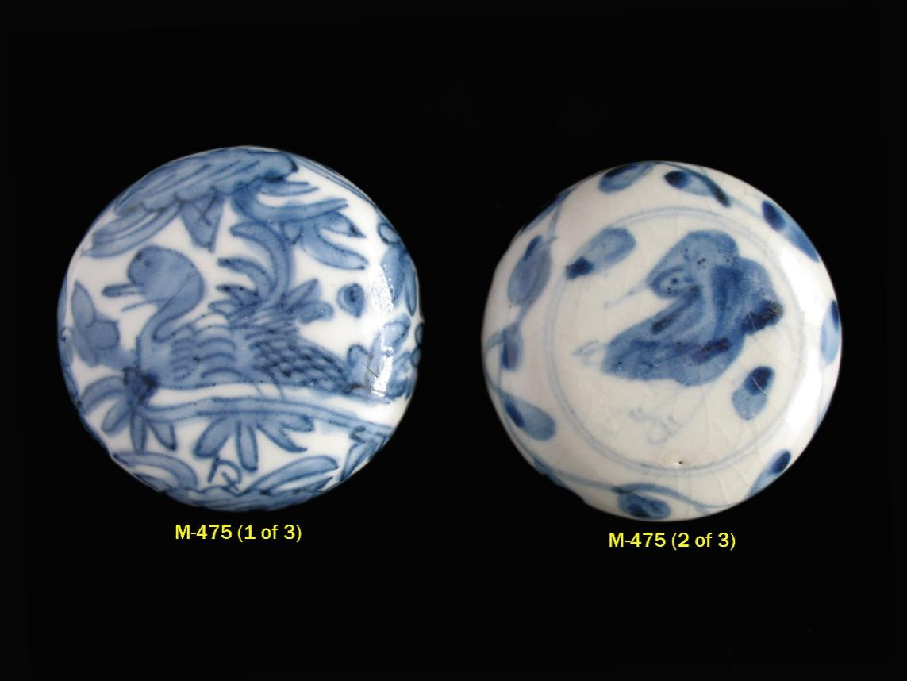

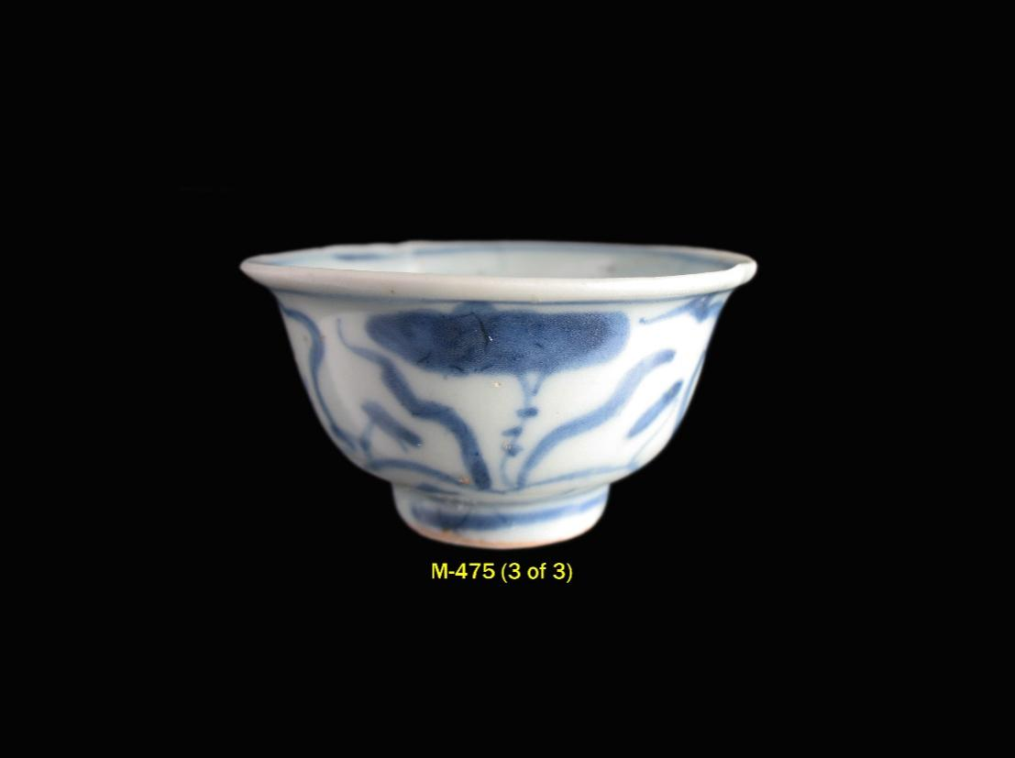

M-503 **MUSI RIVER, PALEMBANG, SUMATRA - MING EXCAVATIONS**

Swatow ceramic covers (3) recovered from the Musi River, Palembang, Sumatra and decorated in underglaze blue in a variety of motifs. Each cover glazed on the interior except for the edge of rim and adjacent area, and the exposed body on all is compact. The matrix below provides a description and the diameter (D) in centimeters of each.

Ming: mid 16th century to early 17th century.

Provenance: Musi River excavations, Palembang, Sumatra, Indonesia - acquired in Jakarta Timur from itinerant vendors from Palembang (April 2016).

|  |  |  |
| --- | --- | --- |
| **SWATOW CERAMIC COVERS**  **RECOVERED FROM THE MUSI RIVER, PALEMBANG**  **M-503 (1 of 3) to M-503 (3 of 3)** | | |
| **CATALOGUE**  **NUMBER** | **DESCRIPTION** | **D**  **CM** |
| M-503  (1 of 3) | An egret reserved on white against a blue shaded lotus blossom ground and enclosed within an undulating band border adorns the flattened top; on the sides four floral spray medallions filled alternately with a peach spray and a ribboned gourd, and separated by vertical brackets joined at the top by a scalloped line border. Exposed body at and just above rim on the interior compact and buff colored. | 10.4 |
| M-503  (2 of 3) | Striped bands divide the slightly domed cover into four sections with alternating scallop and checker diaper patterns, and the center is adorned with a stylized flowerhead reserved in white with blue leaf tip accents. At the rim, there are four *ruyi* head lappets with overlapping semi-circular filler elements on the striped bands. Exposed body is compact and darkish cream colored. | 7.4 |
| M-503  (3 of 3) | A duck in an aquatic scene among lotus and other water plants adorns this slightly domed cover. Exposed body is compact and light beige colored. | 7.3 |

(Continued)

M-503 (Continued)

For further information on the Musi River excavations in Palembang, Sumatra refer to catalogue entry M-459.

**REFERENCES**

**M-503 (2 of 3)** – boxes with very similar covers werefoundon the Swatow Indonesia wreck and M-488 (1 of 5) from that wreck most closely resembles this example. Refer also to M-459 (21 of 22), another very similar cover, and also recovered from the Musi River.

See as wella similar smaller cover box at M-281 from the Selayar Island, South Sulawesi excavations, in Indonesia; and compare with the cover very similar in shape and design concept illustrated in Honda and Shimazu, *Vietnamese and Chinese Ceramics Used in the Japanese Tea Ceremony*, page 153, Plate 143. There is also another similarly decorated cover box in the collection of the Southeast Asian Ceramics Museum (SEACM), Bangkok University (Acquisition Number - SC.677 (2.1)) - refer to photo M-281 & M-459 (Reference - SEACM, Bangkok University).

**M-503 (3 of 3)** - similar covered boxes are illustrated in Sumarah Adhyatman, *Zhangzhou (Swatow) Ceramics: Sixteenth to Seventeenth Centuries Found in Indonesia,* page 134,No. 172a and No. 172b; Columbus Museum of Art, *Shadow of the Dragon - Exhibition Catalogue*, No. 133; K. Aga-Oglu, *The Williams Collection of Far Eastern Ceramics*, No. 30: and Honda and Shimazu, *Vietnamese and Chinese Ceramics Used in the Japanese Tea Ceremony*, page 151, Plate 138. Refer also to M-217 for a set of three similar cover boxes from the South Sulawesi excavations in Indonesia. Compare as well with M-475 (1 of 3), another Swatow cover with duck motif, and also recovered from the Musi River.

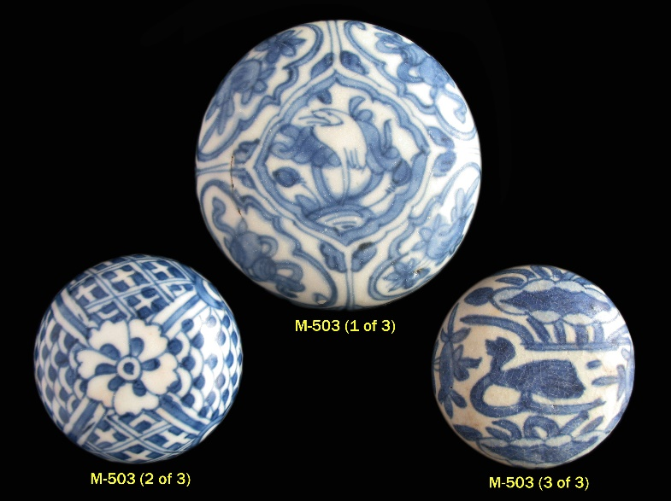

Y-134 **MUSI RIVER, PALEMBANG, SUMATRA - YUAN EXCAVATIONS**

Yuan ceramics (3) recovered from the Musi River, Palembang, Sumatra consisting of a celadon bird feeder shape vessel (1), a small celadon bowl (1), and a small yingqing quadrangular form jarlet (1).

The matrix below summarizes each of the ceramics in terms of form, general description, and diameter (D) or height (H) in centimeters of each individual item.

Yuan (1271 to 1378): 13th century.

Provenance: Musi River excavations, Palembang, Sumatra, Indonesia - acquired in Palembang (April 2013).

For further information on the Musi River excavations in Palembang, Sumatra refer to catalogue entry M-459.

**REFERENCES**

**Y-134 (1 of 3** - a very similar vessel is illustrated in L. and C. Locsin, *Oriental Ceramics Discovered in the Philippines*, page 174, No. 178 - right; compare also with the shard shown on Page 62, No. 183, in Feng Xianming, *Exhibition of Ceramic Finds from Ancient Kilns in China*. Refer as well to Y-144 (3 of 3) for another celadon bird feeder shape vessel in this series, also from the Musi River excavations.

(Continued)

Y-134 (Continued)

|  |  |  |  |
| --- | --- | --- | --- |
| **YUAN CERAMICS RECOVERED FROM MUSI RIVER, PALEMBANG**  **Y-134 (1 of 3) to Y-134 (3 of 3)** | | | |
| **CATALOGUE**  **NUMBER** | **FORM** | **DESCRIPTION** | **D/H**  **CM** |
| Y-134  (1 of 3) | Bird Feeder shape Vessel | Strongly sloping angular sides constricting at the upright mouthrim with two small loop handles just below, the light grayish green opaque glaze covers the interior and ends just below the four lightly incised rings at the shoulders; rather coarse textured light gray body with brownish tingeing, base is slightly concave and narrow. | D: 8.5 |
| Y-134  (2 of 3) | Small Bowl | Steep sides with upright mouthrim, the light grayish green opaque glaze covers the interior and ends unevenly just above the slightly concave base without footrim; exposed body is rather coarse textured and light gray colored with brownish tingeing, | D: 7.2 |
| Y-134  (3 of 3) | Yingqing Jarlet | Small yingqing quadrangular form jarlet lightly molded on both sides with what appears to be a floral spray or aquatic plants; scoop mouth flanked by two small loop handles; flat unglazed base with compact sugary textured white body; the two molded halves of the jarlet are luted together vertically. | H: 4.8 |

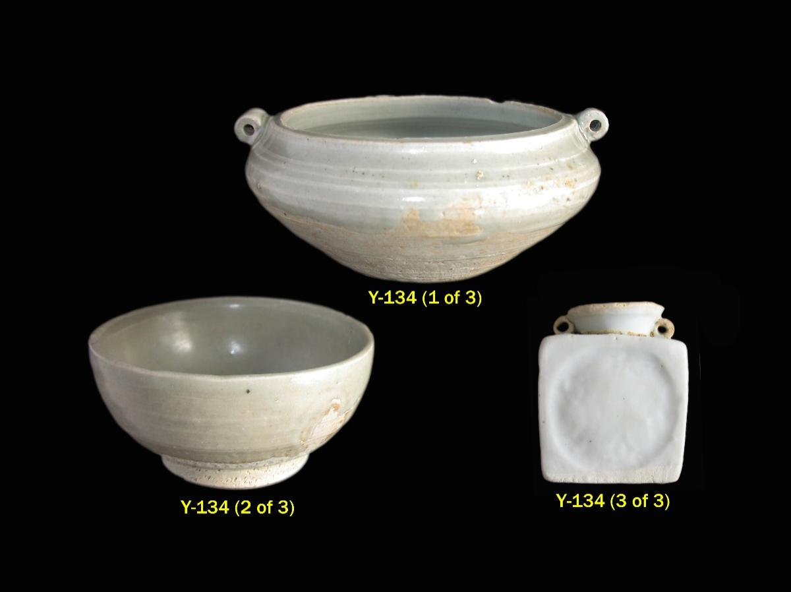

Y-144 **MUSI RIVER, PALEMBANG, SUMATRA - YUAN EXCAVATIONS**

Yuan ceramics (3) recovered from the Musi River, Palembang, Sumatra consisting of a small celadon deep dish (1), a small celadon jarlet (1), and a celadon bird feeder shape vessel (1).

The matrix below summarizes each of the ceramics in terms of form, general description, and diameter (D) or height (H) in centimeters of each individual item.

Yuan (1271 to 1378): 13th to early 14th century.

Provenance: Musi River excavations, Palembang, Sumatra, Indonesia - acquired in Palembang (April 2014).

For further information on the Musi River excavations in Palembang, Sumatra refer to catalogue entry M-459.

**REFERENCES**

**Y-144 (3 of 3)** - a very similar vessel is illustrated in L. and C. Locsin, *Oriental Ceramics Discovered in the Philippines*, page 174, No. 178 - right; compare also with the shard shown on Page 62, No. 183, in Feng Xianming, *Exhibition of Ceramic Finds from Ancient Kilns in China*. Refer as well to Y-134 (1 of 3) for another celadon bird feeder shape vessel in this series, also from the Musi River excavations.

(Continued)

Y-144 (Continued)

|  |  |  |  |
| --- | --- | --- | --- |
| **YUAN CERAMICS RECOVERED FROM MUSI RIVER, PALEMBANG**  **Y-144 (1 of 3) to Y-144 (3 of 3)** | | | |
| **CATALOGUE**  **NUMBER** | **FORM** | **DESCRIPTION** | **D/H**  **CM** |
| Y-144  (1 of 3) | Deep Dish | Celadon deep dish with bucket-shaped sides and upright mouthrim thickened at the edge on the underside. In the central medallion a very lightly incised floral spray; the sides plain. The light mint green glaze extends to the recessed base without footrim; base is convex and unglazed, with very compact light gray colored body. | D: 11.3 |
| Y-144  (2 of 3) | Jarlet | Celadon jarlet with globular *kuan* shaped body, high constricted neck, medium sized aperture, and covered with light sea-green glaze. A band of two distinctly incised ridges encircles the upper shoulders. Narrow base is slightly concave and unglazed with compact, light brownish gray colored body. | H: 5.7 |
| Y-144  (3 of 3) | Bird Feeder Shape Vessel | Strongly sloping angular sides constricting at the upright mouthrim with two small loop handles just below; the light grayish green opaque glaze, mottled in areas, covers the interior and ends just above the unglazed base, which is very slightly concave and narrow with compact russet colored biscuit. | D: 7.5 |

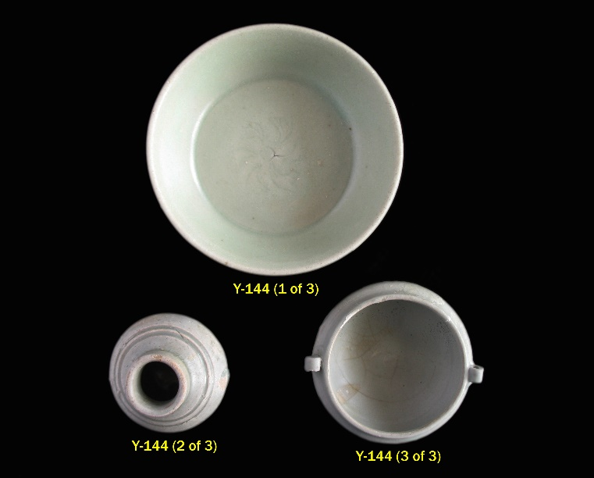

Y-156 **MUSI RIVER, PALEMBANG, SUMATRA - YUAN EXCAVATIONS**

Celadon iron-brown spotted jarlet (fragment), the rather compressed *kuan* shape body accented with three tripartite clusters of mottled blackish brown irregularly shaped iron spots. The light sea green glaze covers the upright beveled mouthrim, extends into the interior, and ends unevenly at and above the strongly beveled footrim. Foot is vertical on the interior, and the narrow unglazed base is flat with fairly compact beige colored body. The interior of this robustly potted jarlet is lightly glazed.

D: 3 3/16 in. (8.1 cm.).

Yuan (1271 to 1368): early to mid 14th century.

Provenance: Musi River excavations, Palembang, Sumatra, Indonesia - acquired in Jakarta Timur from itinerant vendors from Palembang (April 2016).

Compare with similar iron-brown spotted celadon jarlets illustrated in Bureau of Cultural Properties, Ministry of Culture and Information, *Relics Salvaged from the Seabed off Sinan*, page 74, Plate 62, No. 88; Southeast Asian Ceramic Society, *Chinese Celadons and Other Related Wares in Southeast Asia*, page 195, No. 157, PL 121; Zhejiang Provincial Museum, *Sailing from the Great Yuan Dynasty: Relics Excavated from the Sinan Shipwreck*, No. 242; and in *Oriental Ceramics, The World’s Great Collections*, Vol. 3, Museum Pusat, Jakarta, Plate 144 (found on Salayar Island, South Sulawesi).

For further information on the Musi River excavations in Palembang, Sumatra refer to catalogue entry M-459.

S-086 **MUSI RIVER, PALEMBANG, SUMATRA - SONG EXCAVATIONS**

Song ceramics (3) recovered from the Musi River, Palembang, Sumatra consisting of a shallow bowl (1) and two covers (2). The matrix below summarizes each of the ceramics in terms of form, general description, and diameter (D) in centimeters of each individual item.

Song: Five Dynasties (907 to 960) to Northern Song -10th century, No. 1 and No. 2; Northern Song (960 to 1127) - 11th to 12th century, No. 3.

Provenance: Musi River excavations, Palembang, Sumatra, Indonesia - acquired in Palembang (April 2013).

For further information on the Musi River excavations in Palembang, Sumatra refer to catalogue entry M-459.

|  |  |  |  |
| --- | --- | --- | --- |
| **SONG CERAMICS RECOVERED FROM MUSI RIVER, PALEMBANG**  **S-086 (1 of 3) to S-086 (3 of 3)** | | | |
| **CATALOGUE**  **NUMBER** | **FORM** | **DESCRIPTION** | **D**  **CM** |
| S-086  (1 of 3) | Shallow Bowl | Yue yao greenware shallow bowl with flared mouthrim, the central medallion is encircled by an incised line; the dark sea green opaque glaze extends to the footrim and continues onto the flat base, splayed foot is strongly outward slanting on the interior; the body where exposed at the unglazed footrim and at the fractures is compact and dark gray colored. | D: 13.1 |
| S-086  (2 of 3) | Cover | Yue yao greenware cover with sea green opaque glaze and lotus bud knob encircled by a raised molded band; prominent incised line surrounding the rim with two small circular perforations above; interior unglazed with compact gray colored body with brownish tinge. | D: 7.7 |
| S-086  (3 of 3) | Cover | White glazed cover with nominally faceted sides, a lightly molded blossom in the center encircled by a similarly molded ring; interior lightly glazed. | D: 8.1 |

S-088 **MUSI RIVER, PALEMBANG, SUMATRA - SONG EXCAVATIONS**

Song ceramics (10) recovered from the Musi River, Palembang, Sumatra consisting of five covers, two brush washer shaped receptacles, a small jarlet, a small dish, and a stemcup fragment. The matrix below summarizes each of the ceramics in terms of form, general description, and diameter (D) or height (H) in centimeters of each individual item.

Song: Five Dynasties (907 to 960) to Northern Song (10th century) - Yue yao ware.

Provenance: Musi River excavations, Palembang, Sumatra, Indonesia - acquired in Palembang (April 2014).

For further information on the Musi River excavations in Palembang, Sumatra refer to catalogue entry M-459.

|  |  |  |  |
| --- | --- | --- | --- |
| **SONG CERAMICS RECOVERED FROM MUSI RIVER, PALEMBANG**  **S-088 (1 of 10) to S-088 (4 of 10)** | | | |
| **CATALOGUE**  **NUMBER** | **FORM** | **DESCRIPTION** | **D**  **CM** |
| S-088  (1 of 10) | Cover | Large greenware cover with sea green opaque glaze, an incised band sets off the flattened top from the sides; interior glazed, compact gray colored body at the unglazed rim. | D: 9.2 |
| S-088  (2 of 10) | Cover | Greenware cover with olive green opaque glaze, an incised band sets off the flattened top from the sides; interior glazed, compact gray colored body with russet tinges at the unglazed rim. | D: 7.1 |
| S-088  (3 of 10) | Cover | Greenware cover with an incised band setting off the flattened top from the sides; compact gray colored body, sea green opaque glaze now eroded. | D: 7.1 |
| S-088  (4 of 10) | Cover | Greenware cover with an incised band setting off the slightly domed top from the sides; compact gray colored body, sea green opaque glaze now eroded. | D: 6.9 |

(Continued)

S-088 (Continued)

|  |  |  |  |
| --- | --- | --- | --- |
| **SONG CERAMICS RECOVERED FROM MUSI RIVER, PALEMBANG**  **S-088 (5 of 10) to S-088 (10 of 10)** | | | |
| S-088  (5 of 10) | Cover | Greenware cover with an incised band setting off the slightly flattened from the sides; compact gray colored body, olive green opaque glaze now eroded. | D: 6.8 |
| S-088  (6 of 10) | Brush Washer | Greenware globular brush washer shaped receptacle with the wide mouth surrounded by an incised ring, the olive green colored glaze now degraded; dark putty colored compact body where exposed at upright foot with beveled edge and at the convex base, interior lightly glazed. | D: 7.4 |
| S-088  (7 of 10) | Brush Washer | Greenware globular brush washer shaped small receptacle with finely crackled light olive green glaze and wide mouth with slightly upward projecting rim; body where exposed at inward slanting footrim is compact and light gray colored with russet tingeing, lightly glazed base is narrow and convex; interior of this thinly potted vessel is lightly glazed. | D: 5.9 |
| S-088  (8 of 10) | Small  Vase | Greenware vase with ovoid body, extended neck, strongly flared mouthrim and very narrow mouth; neck is encircled at the bottom by a raised ridge and expands upward to the flattened mouthrim with rounded edge, high on the shoulders are two incised ridges. The lightly applied sea green opaque glaze extends to the foot and continues onto the base; upright foot is surmounted by a lightly carved ridge, beveled at rim and slants outward on the interior; narrow base is concave, body where exposed is compact and gray colored. | H: 7.1 |
| S-088  (9 of 10) | Dish | Greenware small dish with flaring thinly potted sides and upright mouthrim, the mottled dark green opaque glaze extends to the foot and continues onto the base. Flaring glazed foot with thin rim slightly beveled on the interior edge, glazed base is flat; body where exposed is fine grained, compact and light gray colored. | D: 13.0 |
| S-088  (10 of 10) | Stemcup | Greenware stemcup fragment, the light sea green opaque glaze thinly applied; crisply carved with a band of double outlined lotus leaves on the sides, a double line border encircles the mouthrim. Foot surmounted by a brief flange and beveled at the rim, stem is hollow; the interior unglazed with very fine grained, compact light gray colored body. | D: 11.3 |

S-093 **MUSI RIVER, PALEMBANG, SUMATRA - SONG EXCAVATIONS**

Song ceramic covers (5) recovered from the Musi River, Palembang, Sumatra. All are greenware covers variously molded and incised and with lotus bud knob (except cover No. 5). The exposed body on all is fine grained and ranging in color from gray to cream. The matrix below provides a description and the diameter (D) in centimeters of each.

Song: Five Dynasties (907 to 960) to Northern Song (10th century) - Yue yao ware.

Provenance: Musi River excavations, Palembang, Sumatra, Indonesia - acquired in Jakarta Timur from itinerant vendors from Palembang (April 2016).

For further information on the Musi River excavations in Palembang, Sumatra refer to catalogue entry M-459.

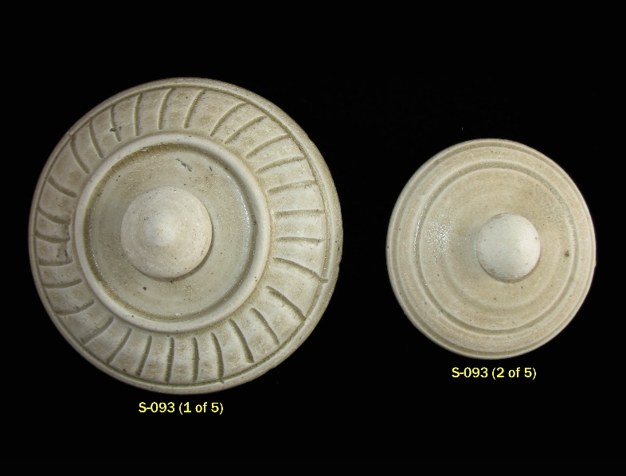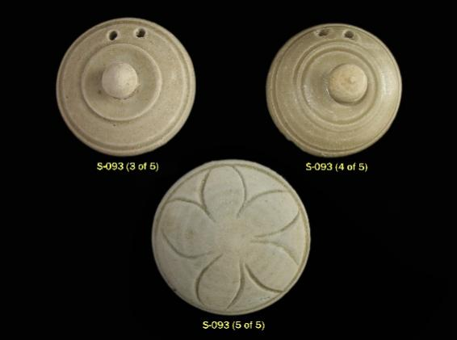

(Continued)

S-093 (Continued)

|  |  |  |
| --- | --- | --- |
| **SONG CERAMIC COVERS**  **RECOVERED FROM MUSI RIVER, PALEMBANG**  **S-093 (1 of 5) to S-093 (5 of 5)** | | |
| **CATALOGUE**  **NUMBER** | **DESCRIPTION** | **D**  **CM** |
| S-093  (1 of 5) | Large greenware cover with sea green mottled glaze, lotus bud knob surrounded by a molded raised ridge; incised strokes radiating down slanted sides to band incised just above rim; interior glazed, exposed body at rim and flange light gray colored. | 10.9 |
| S-093  (2 of 5) | Lotus bud knob with two incised circles surrounding the very slightly domed cover, light olive hued glaze; interior unglazed, body cream colored. | 7.5 |
| S-093  (3 of 5) | Lotus bud knob with two raised ridges surrounding the very slightly domed cover, small twin circular apertures near edge of rim; interior unglazed, extremely light gray colored body; original sea green opaque glaze now eroded. | 6.7 |
| S-093  (4 of 5)) | Lotus bud knob with three incised circles surrounding the slightly domed cover, small twin circular apertures near edge of rim; light olive hued mottled glaze; interior, flange, and underside of rim completely glazed. | 6.5 |
| S-093  (5 of 5) | Carved five petaled blossom extends across the slightly domed cover, an incised circle at the edge; sea green glaze now substantially eroded; slight traces of glaze on interior, body gray colored. | 7.5 |

TH-549 **MUSI RIVER, PALEMBANG, SUMATRA - THAI EXCAVATIONS**

Thai ceramics (10) recovered from the Musi River, Palembang, Sumatra comprising a jarlet (1) and various covers (9). The cover treatments consist of the following: incised decor filled with cream glaze on a caramel-brown glaze ground, underglaze iron-black, brown glaze accents, brown glaze on cream slip, incised motifs glazed brown, and various combinations thereof. The body of the covers is smooth and compact in texture and light beige colored (ranging in a couple of examples to light brown). The jarlet has a more coarse textured body with extensive russet tingeing at the base. The Interior of all the covers and the jarlet is unglazed. The matrix below summarizes each of the ceramics in terms of form, general description, and diameter (D) or height (H) in centimeters of each individual item.

Sisatchanalai: late 15th century to 16th century - Ban Payang kilns.

Provenance: Musi River excavations, Palembang, Sumatra, Indonesia - acquired in Palembang (April 2013).

Palembang, Sumatra is located 90 kilometers up the Musi River and is one of the oldest cities in Indonesia, continuously inhabited since the seventh century. From the seventh to eleventh centuries it was the site of the capital of the Sriwijaya empire. The Musi River has been a major commercial route for 2,000 years, and habitation sites and dwellings in ancient Palembang were located on the river as well

as above it.

(Continued)

TH-549 (Continued)

Ceramics recovered from the Musi River include Chinese export wares dating from the Tang period to the Qing dynasty and featuring most prominently Five Dynasties Yue yao greenware, Longquan Yuan celadons, and Ming Swatow wares. Vietnamese wares, dating from the 14th to 16th century have also been recovered, including celadons as well as blue and white wares. Thai ceramics have been recovered as well, including Sisatchanalai 15th to 16th century underglaze black decorated wares, wares with cream and brown glaze and incised décor, and celadons. Ceramics from the Musi River are represented in the collection by the following: C-159 (1 to 8 of 8), M-459 (1A to 22 of 22), Y-134 (1 to 3 of 3), S-086 (1 to 3 of 3), TH-549 (1 to 10 of 10), and V-265 (1 to 4 of 4).

**REFERENCES**

**TH-549 (2 of 10)** - similar covered boxes are illustrated in K. Aga-Oglu, *The Williams Collection of Far Eastern Ceramics: Tonnancour Section*, No. 195; the Art Gallery of South Australia, *Thai Ceramics*, No. 189; and R. Brown, *The Ceramics of South-East Asia*, Plate R,

No. 3; Christie’s (Melbourne), *Catalogue of The Brake-Lau-Eckermann Collection of South East Asian Ceramics, Textiles and Works of Art*, September 3, 1990, page 29 - lower right; and Sotheby’s (New York), *Catalogue of South-East Asian and Early Chinese Export Ceramics*, October 4, 1974, lot 33. Refer also to the very similar cover box at TH-154 (No. 1 of 2) from the South Sulawesi excavations, Indonesia.

**TH-549 (9 of 10)** - similar covers are illustrated in J. Guy, *Oriental Trade Ceramics in Southeast Asia*, No. 131; and C. Nelson Spinks, *The Ceramic Wares of Siam*, Plate 47. Refer also to very similar covers at TH-147 from the Ban Payang kiln site excavations in Thailand; TH-274 from the Kintalan/Maros, South Sulawesi excavations in Indonesia; and TH-303 (No. 1 of 2) from the Selayar Island, South Sulawesi excavations in Indonesia.

**TH-549 (10 of 10)** - refer to the similar cover box at TH-163 from the South Sulawesi excavations in Indonesia. (Continued)

TH-549 (Continued)

|  |  |  |  |
| --- | --- | --- | --- |
| **THAI CERAMICS RECOVERED FROM THE MUSI RIVER, PALEMBANG**  **TH-549 (1 of 10) to TH-549 (7 of 10)** | | | |
| **CATALOGUE**  **NUMBER** | **FORM** | **DESCRIPTION** | **D/H**  **CM** |
| TH-549  (1 of 10) | Jarlet | Decorated on the elongated globular body in brown glaze cross-hatching with dot shaped filler, enclosed within line borders, on top of a light application of cream slip; the short neck and mouthrim edged in brown glaze and encircled by a raised ridge border similarly glazed; unglazed convex base. | H: 5.9 |
| TH-549  (2 of 10) | Cover | A lotus bud handle, surrounded by a double raised ridge border, forms the center for an incised six petaled floral spray filled with cream glaze on a caramel-brown glaze ground extending to the double ridged turn of the lid; the sharply angled sides of the lid incised with a band of triangular pointed leaves filled with cream glaze against the mottled caramel-brown ground. | D: 9.9 |
| TH-549  (3 of 10) | Cover | Description is same as for previous cover, TH-549 (2 of 10), except for a *five* petaled floral spray. | D: 9.7 |
| TH-549  (4 of 10) | Cover | Description is same as for cover at  TH-549 (2 of 10) except for smaller size and more subdued tone of brown glaze. | D: 6.2 |
| TH-549  (5 of 10) | Cover | Description is same as for cover at  TH-549 (2 of 10) except for smaller size, a *seven* petaled floral spray, and flattened vestigial knob handle. | D: 5.6 |
| TH-549  (6 of 10) | Cover | Lotus bud knob handle surrounded by a band of two raised ridges all glazed brown; decorated with six panels containing underglaze iron-black leaf sprays alternating with wide brown glazed raised ridges separated by double vertical line borders, and all enclosed by underglaze black double circular rings. | D: 7.1 |
| TH-549  (7 of 10) | Cover | Small cover with lotus bud handle decorated in underglaze iron-black with a band of leaf sprays enclosed within single line borders. | D: 4.2 |

(Continued)

TH-549 (Continued)

|  |  |  |  |
| --- | --- | --- | --- |
| **THAI CERAMICS RECOVERED FROM THE MUSI RIVER, PALEMBANG**  **TH-549 (8 of 10) to TH-549 (10 of 10)** | | | |
| **CATALOGUE**  **NUMBER** | **FORM** | **DESCRIPTION** | **D**  **CM** |
| TH-549  (8 of 10) | Cover | Small cover with lotus bud handle surrounded by six underglaze iron-black leaf forms, the sharply sloping sides similarly adorned with leaf tips. | D: 4.1 |
| TH-549  (9 of 10) | Cover | Cover with central lotus bud knob encircled by two prominently molded ridges and a wide band of incised scrolling vines - all glazed in dark mottled brown; the cream glazed sides of the cover surmounted by a rounded ridge enclosed within rather deeply incised circular lines. | D: 10.3 |
| TH-549  (10 of 10) | Cover | Tiny knob handle surrounded by a raised band of radiating gouges, all glazed brown; a band of underglaze iron-black leaf tips below; the vertical sides encircled by a single line border. | D: 4.9 |

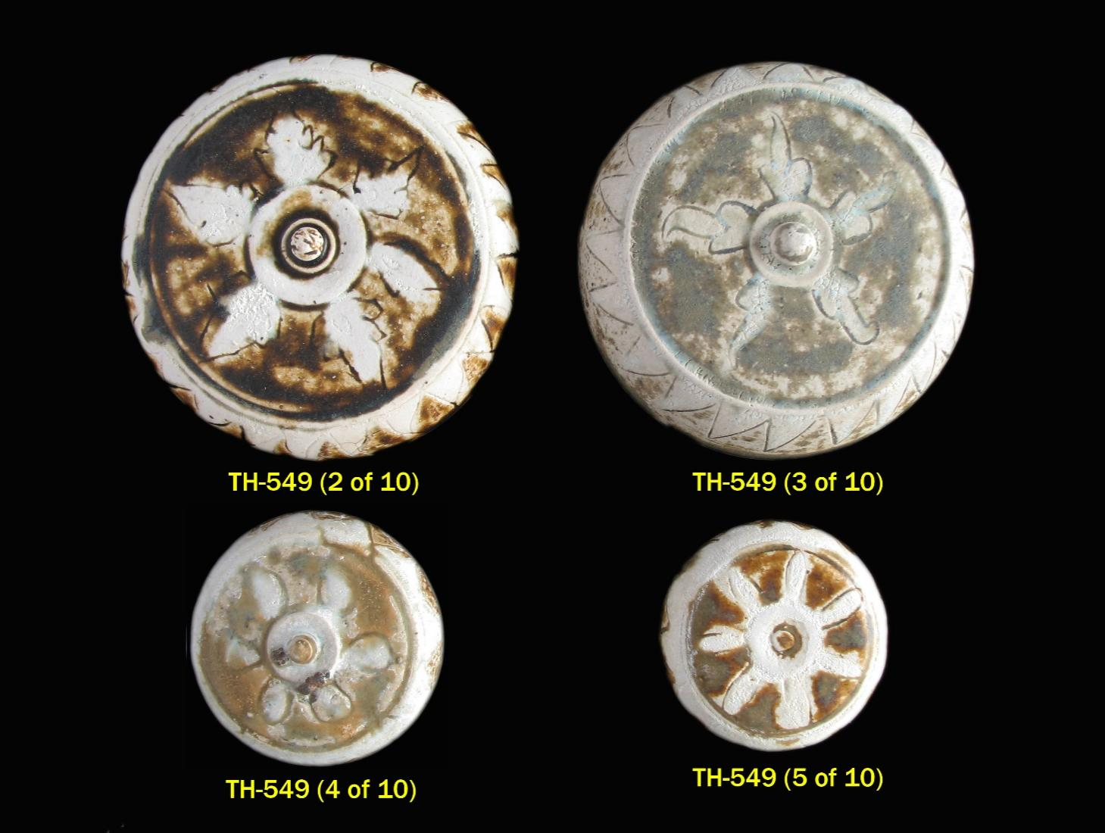TH-566 **MUSI RIVER, PALEMBANG, SUMATRA - THAI EXCAVATIONS**

Sukhothai bowl decorated in underglaze iron-brown on a cream slip under straw-colored glaze. The principal decoration is a *cakra* or solar whorl in the central medallion surrounded by five very small and roughly circular spur marks and a triple line border. The cavetto decorated with a *mongkut*, or tiered crown design, repeated six times and separated by slanted vertical line borders. This is surmounted by a narrow band with etched oblique accents in sgraffito technique and enclosed within double line borders below and at the everted mouthrim. The similarly decorated exterior with seven tiered crowns enclosed within double line borders, and below a band of diagonal stroke marks. The crackled glaze and cream slip end unevenly just above the splayed foot slightly outward sloping on the interior. Flat base is nominally recessed, unglazed and with rather coarse textured light brown colored biscuit sprinkled with white quartz particles.

D: 7 11/16 in. (19.6 cm.).

Sukhothai: late 15th to 16th century.

Provenance: Musi River excavations, Palembang, Sumatra, Indonesia - acquired in Jakarta Timur from itinerant vendors from Palembang (April 2016).

Very similar Sukhothai bowls are illustrated in J. Guy, *Oriental Trade Ceramics in Southeast Asia – 10th to 16th Century*, page 88, No. 123; Hiromu Honda and Noriki Shimazu, *The Beauty of Fired Clay: Ceramics from Burma, Cambodia, Laos and Thailand*, page 188,

(Continued)

TH-566 (Continued)

No. 243; Christie’s (Melbourne), *Catalogue of The Brake-Lau-Eckermann Collection of South East Asian Ceramics, Textiles and Works of Art*, September 3, 1990, page 30, lot 216; Roxanna Brown, *The Ceramics of South-East Asia, Their Dating and Identification* (Second Edition), Plate 34–d; Sato Art Museum Toyama, 2002, Special *Exhibition: South-East Asian Ceramics from the Kamratan Collection*, Vol. 8, page 61, Plate 148; and Yamato Bunkakan/Nara Museum, 1983, *Special Exhibition: South-East Asian Ceramics*, page 52, No. 77. Also, very similarly decorated Sukhothai bowls are represented by the shards at TH-217 (1 of 3), TH-526 (1 of 10), and TH-526 (3 of 10).

For further information on the Musi River excavations in Palembang, Sumatra refer to catalogue entry M-459.

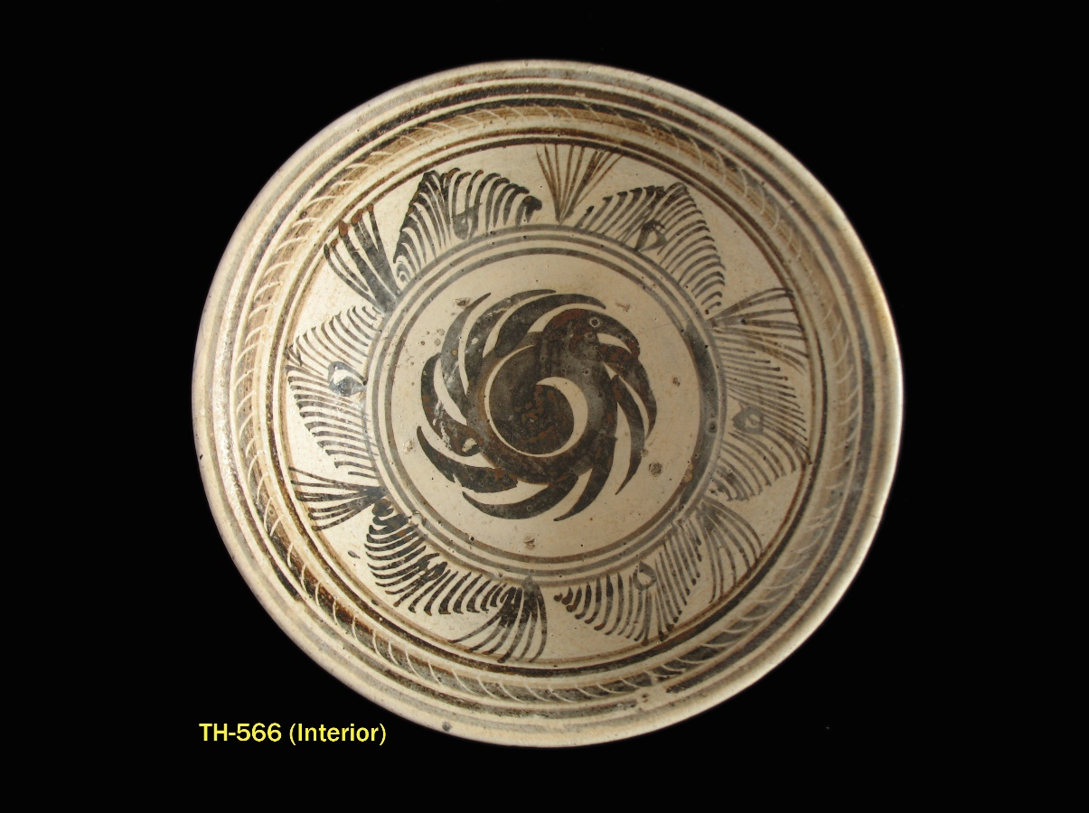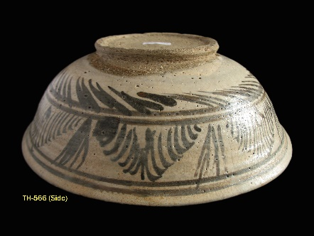

V-265 **MUSI RIVER, PALEMBANG, SUMATRA - VIET EXCAVATIONS**

Vietnamese (Annamese) ceramics (4) recovered from the Musi River, Palembang, Sumatra consisting of two celadon jarlets (2), a shard from a celadon dish (1), and a blue and white cover (1). The matrix below summarizes each of the ceramics in terms of form, general description, and diameter (D) in centimeters of each individual item.

Vietnamese: 14th to 16th century.

Provenance: Musi River excavations, Palembang, Sumatra, Indonesia - acquired in Palembang (April 2013).

Palembang, Sumatra is located 90 kilometers up the Musi River and is one of the oldest cities in Indonesia, continuously inhabited since the seventh century. From the seventh to eleventh centuries it was the site of the capital of the Sriwijaya empire. The Musi River has been a major commercial route for 2,000 years, and habitation sites and dwellings in ancient Palembang were located on the river as well as above it.

Ceramics recovered from the Musi River include Chinese export wares dating from the Tang period to the Qing dynasty and featuring most prominently Five Dynasties Yue yao greenware, Longquan Yuan celadons, and Ming Swatow wares. Vietnamese wares, dating from the 14th to 16th century have also been recovered, including celadons as well as blue and white wares. Thai ceramics have been recovered as well, including Sisatchanalai 15th to 16th century

(Continued)

V-265 (Continued)

underglaze black decorated wares, wares with cream and brown glaze and incised décor, and celadons. Ceramics from the Musi River are represented in the collection by the following: C-159 (1 to 8 of 8), M-459 (1A to 22 of 22), Y-134 (1 to 3 of 3), S-086 (1 to 3 of 3), TH-549 (1 to 10 of 10), and V-265 (1 to 4 of 4).

**REFERENCES**

**V-265 (1 & 2 of 4)** - compare with the jarlets illustrated in

D. Richards, *South-East Asian Ceramics: Thai, Vietnamese, and Khmer*, Plate 100 – center; C. M. Young, *Vietnamese Ceramics*,

No. 18; R. Brown, *The Ceramics of South-East Asia*, Plate 8, No. 26 and Plate 9, No. 30; and Christie’s (London), *Catalogue of Important Annamese Ceramics - The Mr. and Mrs. Robert P. Piccus Collection*, December 7, 1984, lot 20. Refer also to the other similar green glazed jarlets at V-173 from the Pankep, South Sulawesi excavations in Indonesia; and at V-210 (No. 1 and No. 2 of 2) from the Song Doc shipwreck in Vietnam and dated to the late 14th century - circa 1375 to 1400.

**V-265 (4 of 4)** - cover boxes with similar design concept are illustrated in the following: U. Wiesner, *Chinesische Keramik Auf Den Philippinen*, No. 168; *Oriental Ceramics, The World's Great Collections*, Vol. 3, The Museum Pusat, Jakarta, No. 301; Oriental Ceramic Society of Hong Kong, *South-East Asian and Chinese Trade Pottery - Exhibition Catalogue*, No. 203; R. Moes, *Southeast Asian Ceramics* (Brooklyn Museum Exhibition Catalogue), Catalogue number 49; W. Willetts, *Ceramic Art of Southeast Asia*, No. 53; Christie, Manson & Woods (London) *Catalogue of Important Annamese Ceramics - The Mr. and Mrs. Robert P. Piccus Collection*, December 7, 1984, lot 74; and Sotheby Parke Bernet (New York) *Catalogue of South-East Asian and Early Chinese Export Ceramics*, October 4, 1974, lot 9 and lot 12. Refer also to the Vietnamese cover with very similar design concept at M-179 from the South Sulawesi excavations in Indonesia.

(Continued)

V-265 (Continued)

|  |  |  |  |
| --- | --- | --- | --- |
| **VIET CERAMICS RECOVERED FROM THE MUSI RIVER, PALEMBANG**  **V-265 (1 of 4) to V-265 (4 of 4)** | | | |
| **CATALOGUE**  **NUMBER** | **FORM** | **DESCRIPTION** | **D**  **CM** |
| V-265  (1 of 4) | Jarlet | Flattened globular form covered with mottled apple green crackled glaze, broad shoulders curve in very sharply to the rolled lip of the mouth; glaze with a fine network of crackle ends evenly just above the base; the broad flat base is unglazed, and the beige-colored body with russet tingeing is compact with larger inclusions. | D: 6.4 |
| V-265  (2 of 4) | Jarlet | Flattened globular form covered with light sea green crackled glaze, broad shoulders curve in very sharply to the rolled lip of the mouth; glaze with a fine network of crackle ends in an uneven line just above the base; the broad flat base is covered with a heavy application of chocolate wash, body where exposed is compact and light beige colored. | D: 5.7 |
| V-265  (3 of 4) | Shard - base and rim of dish | The flattened mouthrim with foliated edge has a lightly molded band of key fret, repeated in the cavetto; molded peony blossom with incised accents in the central medallion; the lustrous light sea green celadon glaze ends in an even line at the wedge-shaped carefully beveled footrim with light grayish beige-colored compact body; the flat base coated with a chocolate wash. | D: 5.7 |
| V-265  (4 of 4) | Cover | Blue and white octagonal shape cover, the flattened top decorated with a chrysanthemum spray with double-outlined petals framed in a scrolling leafy stem, and encircled by a border of leaf spray panels alternating with cross-hatched diaper. The faceted sides of the cover with four leaf sprays in panels alternating with panels of trefoils in reserve on a cross-hatched ground; interior of the cover partially glazed, with the light buff-colored compact biscuit revealed at the unglazed rim. | D: 6.8 |

**Musi River ceramics (77) - Chinese, Vietnamese and Thai**

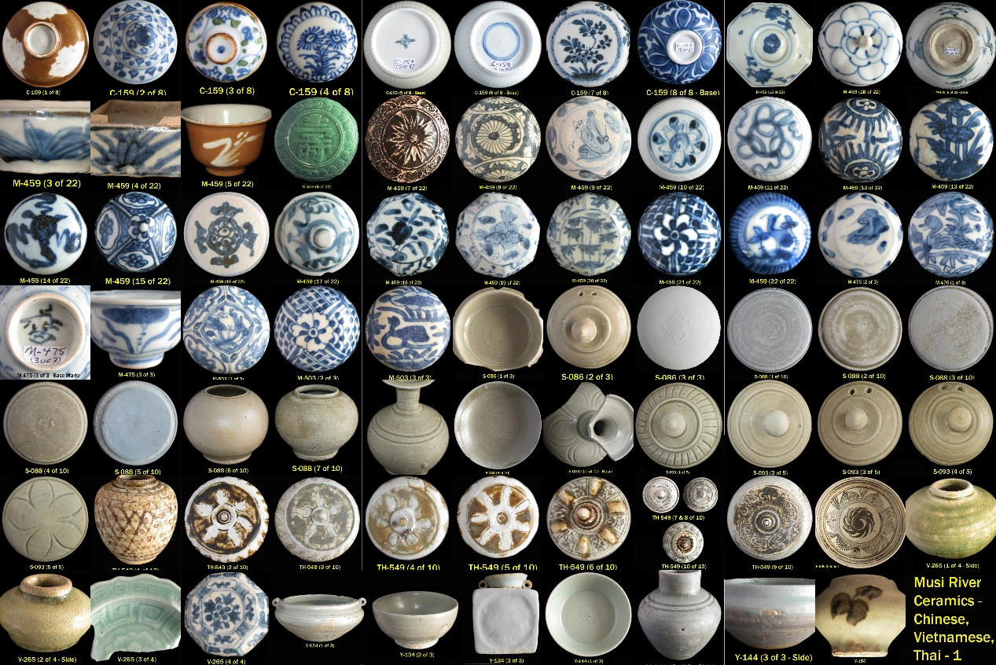

All the above ceramics were acquired in Palembang from villagers and others living near the Musi River (except for the Sukhothai bowl at TH-566, which was acquired in Jakarta from itinerant vendors from Palembang).